History World War Two (1939-1945) Year 6
Key Vocabulary
Air-raid, Anderson shelter, allies, atomic bomb, axis powers, blackout, blitz, concentration camps, evacuation, fascism, Fuhrer, gas masks, genocide, holocaust, invasion, liberated, Luftwaffe, occupied, Nazi, persecution, propaganda, rationing, spitfire

Air-raid | An attack by enemy planes dropping bombs.
Anderson shelter | A small shelter made from corrugated steel to protect people during air-raids.
Allies | Countries (including Britain, France, the Soviet Union and the USA) who fought against the Axis Powers.
Atomic bomb | A powerful weapon that uses nuclear reactions as its source of explosive energy: first used in 1945.
Axis Powers | Germany, Japan, Italy and other countries that fought against the Allies.
Blackout | A wartime ban on streetlights and other lights at night, to reduce the risk of bombing by enemy planes.
Blitz | A prolonged period of German air-raids on Britain from the German ‘blitzkrieg’- ‘lightning war’.
Concentration camps | Prisons where Jewish people and others were held by the Nazis.
Evacuation | Moving people from dangerous areas to safer places e.g. big cities to the countryside to avoid bombing.
Fascism | A political system where the country’s strength is more important than the well-being of the people. Often ruled by dictators with unlimited power through suppression of opposition; strictly controlling society.
Fuhrer | German word: ‘leader’ or ‘guide’. The title Hitler gave himself in 1933 when he gained absolute authority.
Gas masks | Face masks to protect people from poisonous gas attacks.
Genocide | Deliberate action to destroy a people (usually defined as an ethnic, national, racial or religious group).
Holocaust | The mass murder of around six million Jewish people by the Nazis, as well as other persecuted groups.
Invasion | When an army or country uses force to enter and take control of another country or area.
Liberated | Freed from enemy control.
Luftwaffe | The German air force during the war.
Occupied | Taken over by enemy forces.
Nazi | Short for ‘National Socialist Party (in German) and the name given to the supporters of Hitler.
Persecution | Systematic mistreatment of an individual or group, especially because of race, religion or political beliefs.
Propaganda | Information, especially of a biased or misleading nature, used to promote a political cause or point of view.
Rationing | Controlling the supply of food, clothes, petrol and other products to avoid or reduce shortages.
Spitfire | A British aircraft, particularly used during the ‘Battle of Britain’ and known for its speed and agility.
Battle of Britain
A major air campaign fought largley over southern England in the summer of 1940.Germany planned to gain air superiority In preparation for an invasion of Great Britain. We will discover how the RAF deated the Luftwaffe.
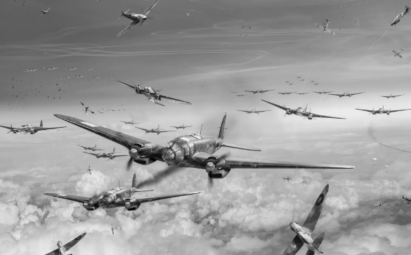
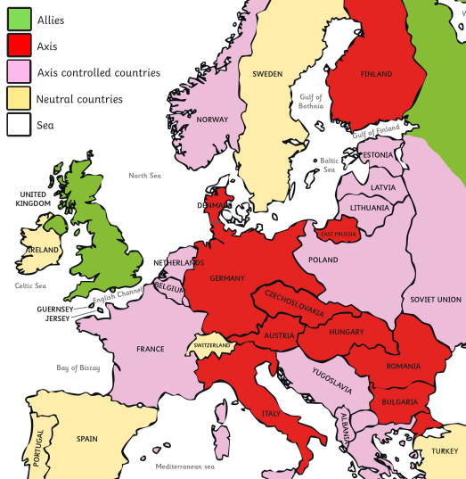

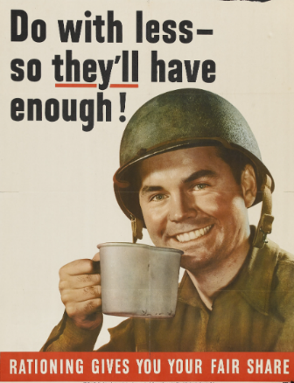
History World War Two (1939-1945) Year 6
Date | Event
1st September 1939 | Hitler invades Poland
3rd September 1939 | Britain (Chamberlain) declares war on Nazi Germany.
May 1940 | Chamberlain resigns and Churchill becomes Prime Minister.
June 1941 | Nazis first invade the Soviet Union (Russia).
December 1941 | Japanese forces bomb Pearl Harbor (USA).
6th June 1944 | Allied forces land on the beaches of France (D-Day).
30th April 1945 | Hitler Dies.
4th May 1945 | Nazi Germany Surrenders.
8th May 1945 | VE (Victory in Europe) Day.
August 1945 | USA drops the atom bomb on Japan.
D-Day
D-Day is the name given to the day when the Normandy Landings took place during World War II.
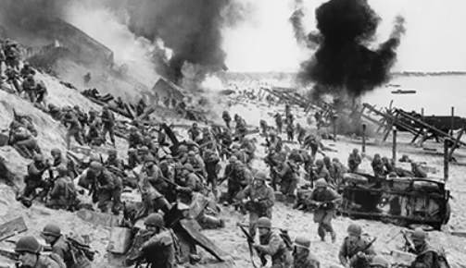

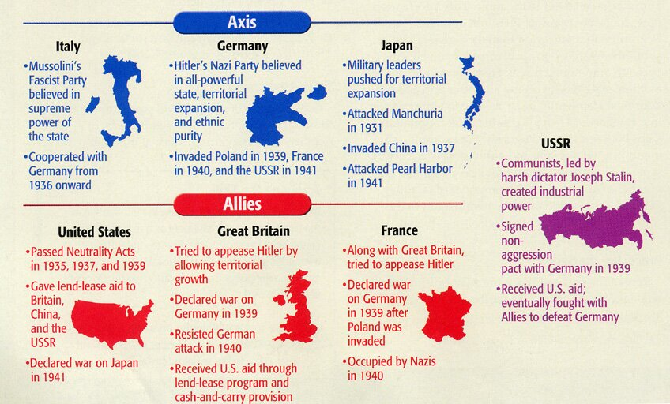
Key Leaders and Places
Leader | Country | Continent | Power
Neville  Chamberlain | United Kingdom | Europe | Allies
Winston  Churchill | United Kingdom | Europe | Allies
Adolf  Hitler | Germany | Europe | Axis
Benito  Mussolini | Italy | Europe | Axis
Franklin D.  Roosevelt | United States of America | North America | Axis
Joseph  Stalin | Russia (Soviet Union) | Europe/Asia | Axis/Allies

