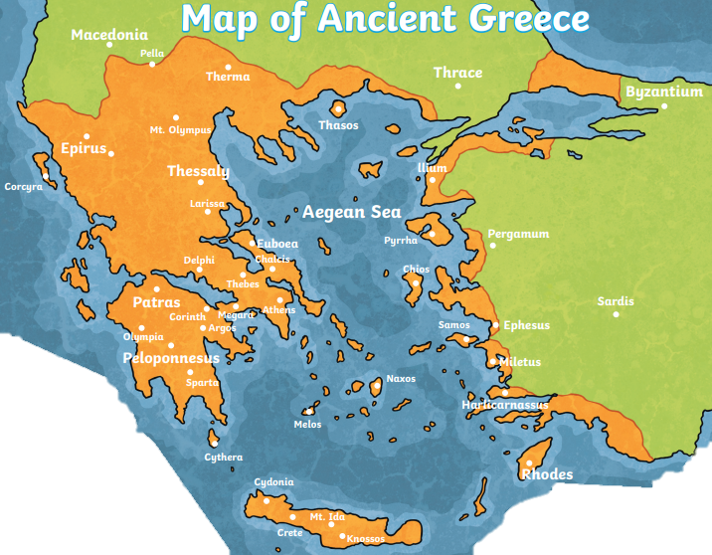

**Ancient Greeks History Year 4**

Nearly four thousand years ago, in the countries that we now know as Greece, Turkey and Bulgaria, the earliest Greek civilisations prospered. Between 2000BC and 146BC, their dominant empire spread throughout most of Europe.

**Greek Gods**

Religion was important to the Greeks because they believed that it would make their lives better while they were living. Furthermore, many Greeks believed that the gods would care for them when they died. The Ancient Greeks believed in a large number of influential gods and goddesses, believing that these gods and goddesses controlled everything in their lives, each having their own responsibilities for different part of life.

**First Olympics 776 BC**

In ancient Greece different city-states often fought one another in deadly battles. However, every four years the Greeks set aside their differences to honour the gods and compete peacefully in the Olympic Games.

**Women in Greece**

In ancient Greece, the lives and men and women was quite different and sometimes were kept quite separate. The role of women was often to stay at home to look after the family, take care of household duties and raise the children whereas man were trained to be good citizens and strong warriors.

**Key Vocabulary**

**Athens –** the capital of Greece and one of the most powerful city states in ancient Greece.

**Greek Mythology** – stories originally told by the ancient Greeks. Usually including a Greek god.

**City States** – a powerful city that ruled the lands and area around it. Sometimes it also ruled smaller less-powerful cities.

**Civilisation** – a human society with its own social organisation and culture.

**Democracy** – ordinary citizens having the opportunity to vote on how their city or country is run.

**Mount Olympus –** Home of the Greek gods.

**Olympic Games** – a festival and variety of sporting events to honour the king of the gods, **Zeus.**

**Polytheism** – believing in more than one god.

**Priestess** – a female religious leader

**Sparta** – one of the most powerful city states in ancient Greece.

**Underworld –** where ancient Greek people believed they went when they died. Ruled by **Hades.**

**A lasting legacy**

The word ‘alphabet’ comes from the first 2 letters in Greek ‘alpha’ ad ‘beta’

Greek system of democracy went on to influence most modern governments. Influences of Greek architecture can still be seen today in the columns of important UK public buildings.

Herodotus was one of the world’s first historians

**Ancient Greek themed fiction books**

**Who Let the Gods Out?** Maz Evans

**Beasts of Olympus: Beast Keeper** Lucy Coats

**Hopeless Heroes: Here Comes Hercules!** Stella Tarakson & Nick Roberts

**Fleeced!** Julia Wills

**Myth-O-Mania series** Kate McCullan