Multiplication
Skill | Year 3 | Year 4 | Year 5 | Year 6
Multiply 2-digit numbers by 1-digit numbers  Resources  - Place value counters  - Base 10 | 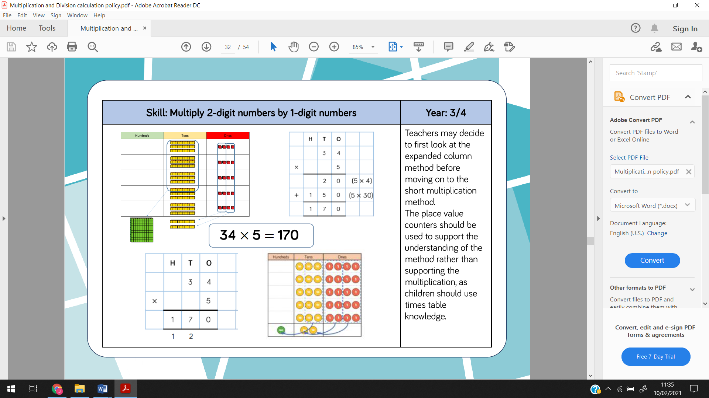  Expanded column method | Short written method
Multiply 3-digit numbers by 1-digit numbers  Resources (move away from using them if you can, especially with larger numbers)  - Place value counters  - Base 10 |  | 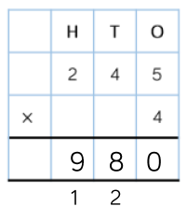  Short written method
Multiply 4-digit numbers by 1-digit numbers  Resources (move away from using them if you can, especially with larger numbers)  - Place value counters |  |  | 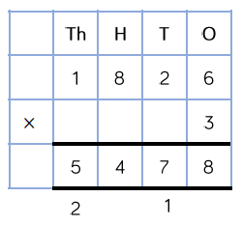  Short written method
Multiply 2-digit numbers by 2-digit numbers  Resources  - Area model and base 10- Link to grid method.  - Place value counters |  |  | 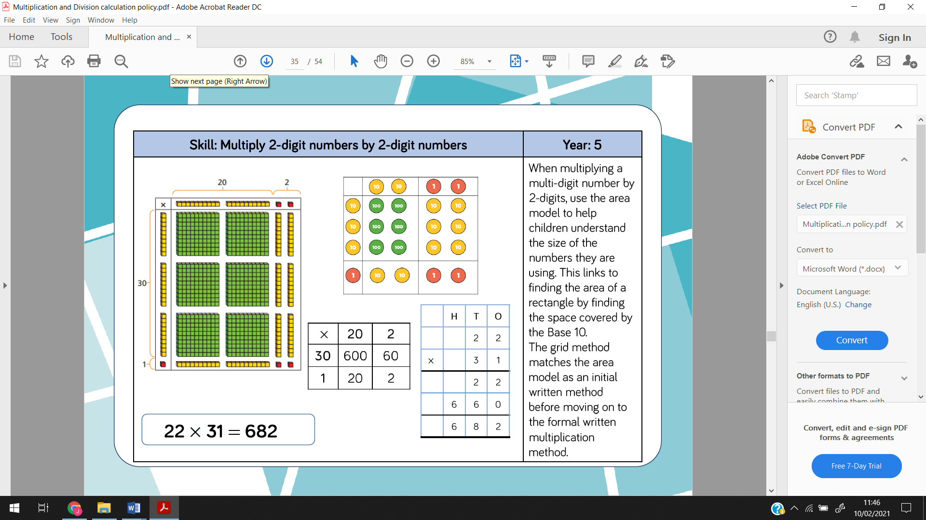  1.  Grid method (link to area model)  2.  Expanded column method
Multiply 3-digit numbers by 2-digit numbers  Resources  - Place value counters, rather than base 10. |  |  | 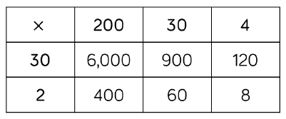  Grid method  See the link between the grid method and the formal written method but move away from grid method and focus on the written method.  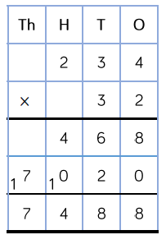  Expanded column method
Multiply 4-digit numbers by 2-digit numbers  Should be confident with the written method that they don’t need resources. |  |  | 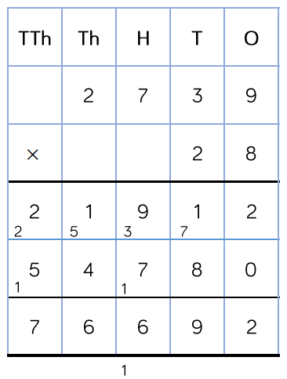  Expanded column method | Expanded column method (Same as Y5)

Division
Skill | Year 2 | Year 4 | Year 5 | Year 6
Divide 2-digits by 1-digit (sharing with no exchange)  Resources  - Base 10  - Place value counters  - Straws | 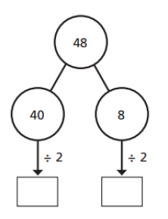  Part whole model- partitioning
Divide 2-digits by 1-digit (sharing with exchange)  Resources  - Base 10  - Place value counters | 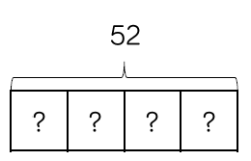  Year 3  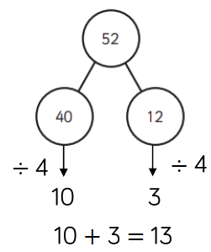  Bar model  Part whole model- partitioning
Divide 2-digits by 1-digit (sharing with remainders)  Resources- to show the exchange  - Base 10  - Place value counters |  | 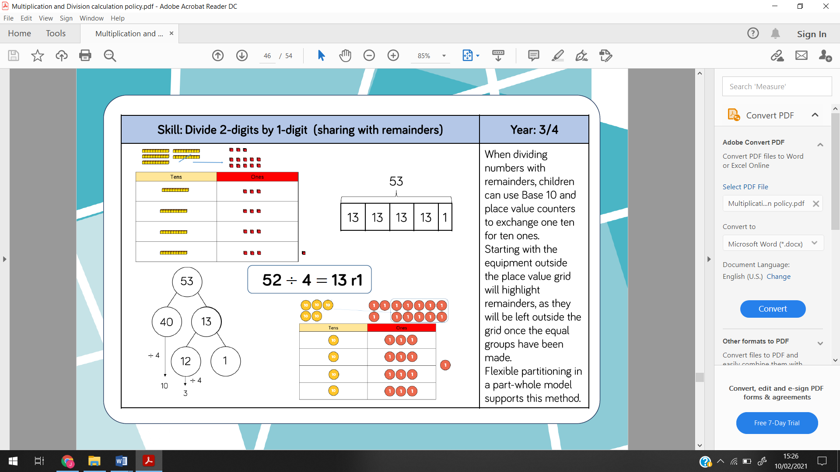  Bar model  Part whole model- partitioning
Divide 2-digits by 1-digit (grouping)  This can involve remainders too.  Language- “How many groups of 4 can we make?”  Resources  - Base 10  - Place value counters |  | 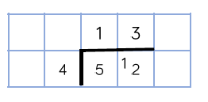  Short division- Grouping by the divisor (4).
Divide 3-digits by 1-digit (sharing)  Resources  - Place value counters |  | 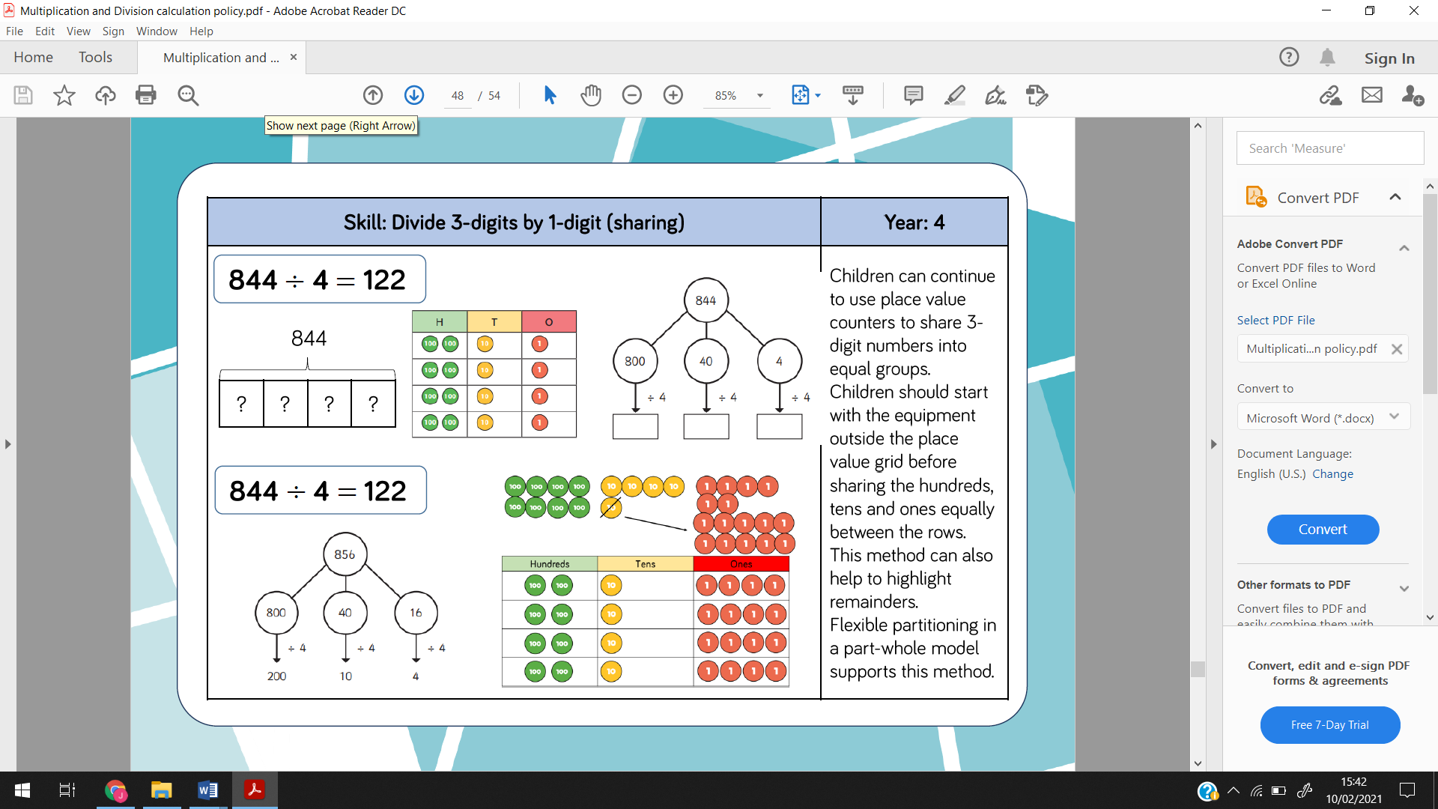  Bar model  Part whole model to partition.
Divide 3-digits by 1-digit (grouping)  Resources  - Place value counters |  |  | 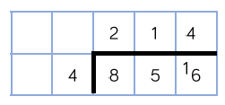  Short division- continue to use grouping to support this method.
Divide 4-digits by 1-digit (grouping)  Resources  - Place value counters  Although, children should be moving away from using them, especially when there is multiple exchanges. |  |  | 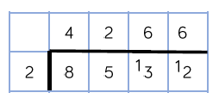  Short division- continue to use grouping to support this method.
Divide multi digits by 2-digit (short division)  No resources should be needed at this stage. If they do, they are not ready for this type of calculation. |  |  | 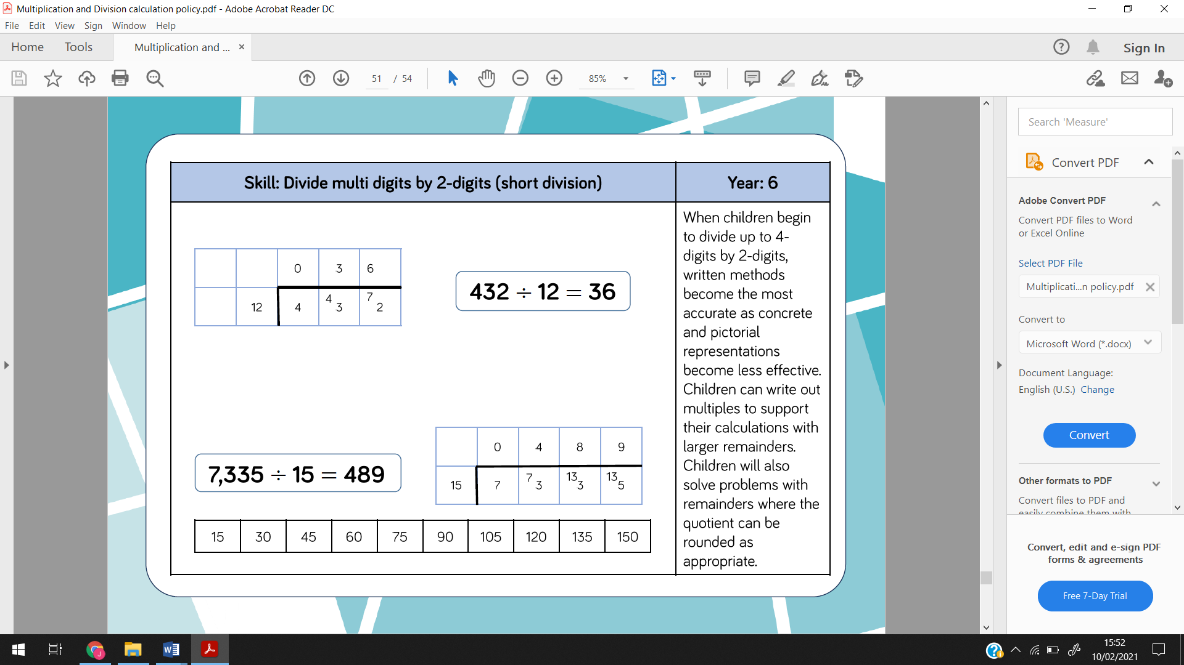  Or  Short division
Divide multi digits by 2-digit (long division)  No resources should be needed at this stage. |  |  |  | 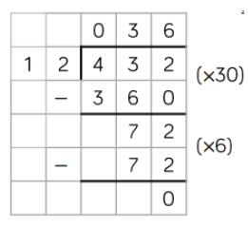  Long division
Divide multi digits by 2-digit (long division with remainders)  No resources should be needed at this stage. |  |  |  | 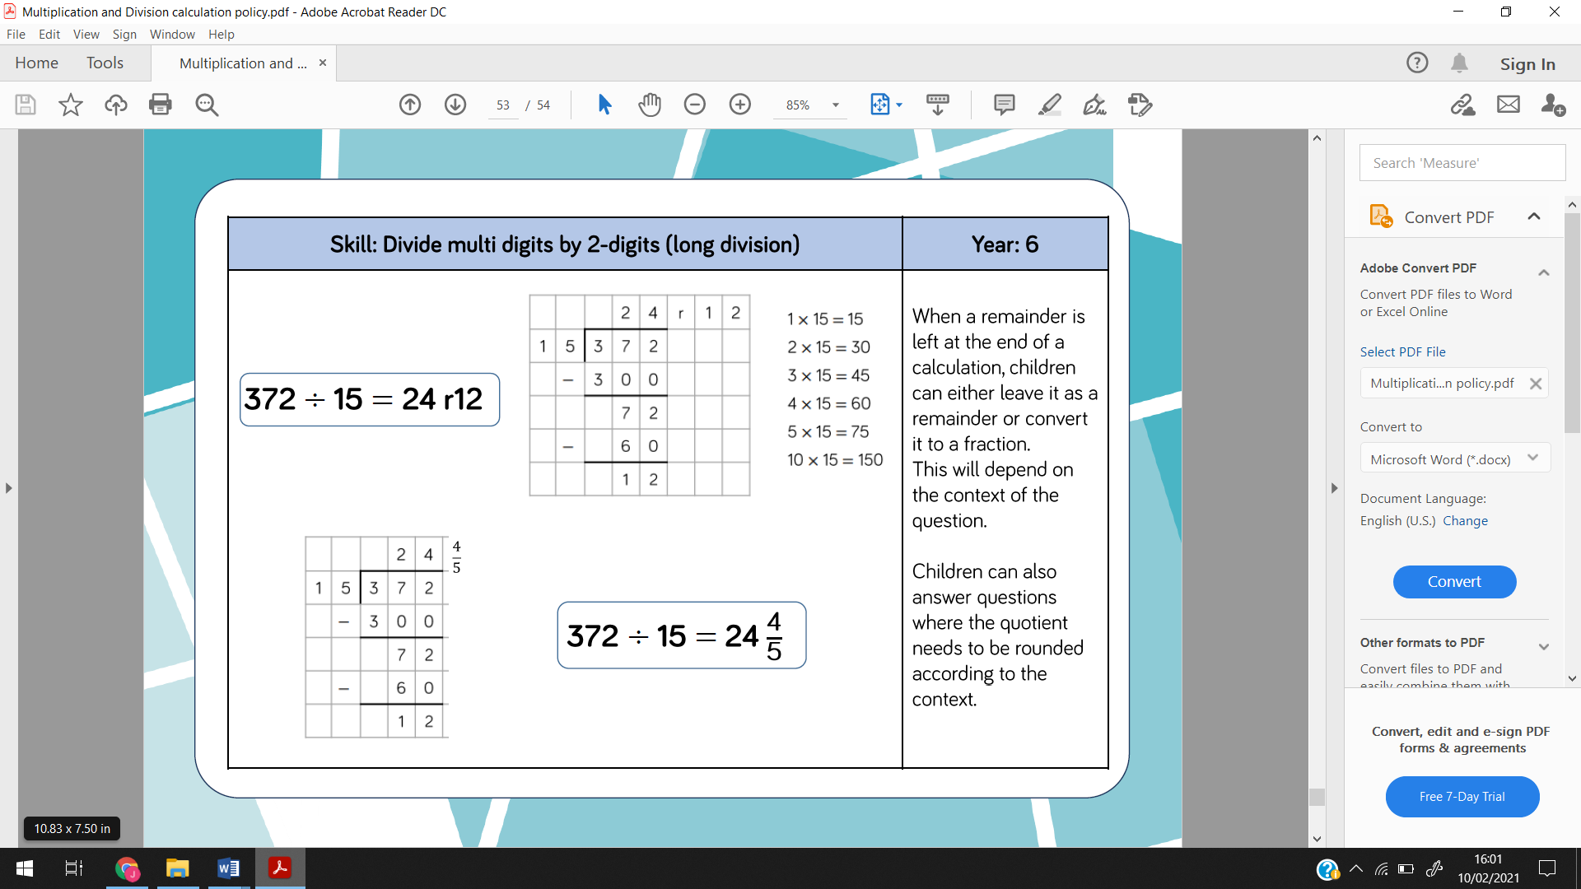  Long division with remainders (as a whole number)  Or  Long division with remainders (as a fraction)  It will depend on the question as to which one is appropraite to use.

Addition
Skill | Year 2 | Year 3 | Year 4 | Year 5
Add two 2-digit numbers to 100 (with no exchange)  Resources  - Base 10  - Place value counters | 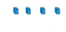  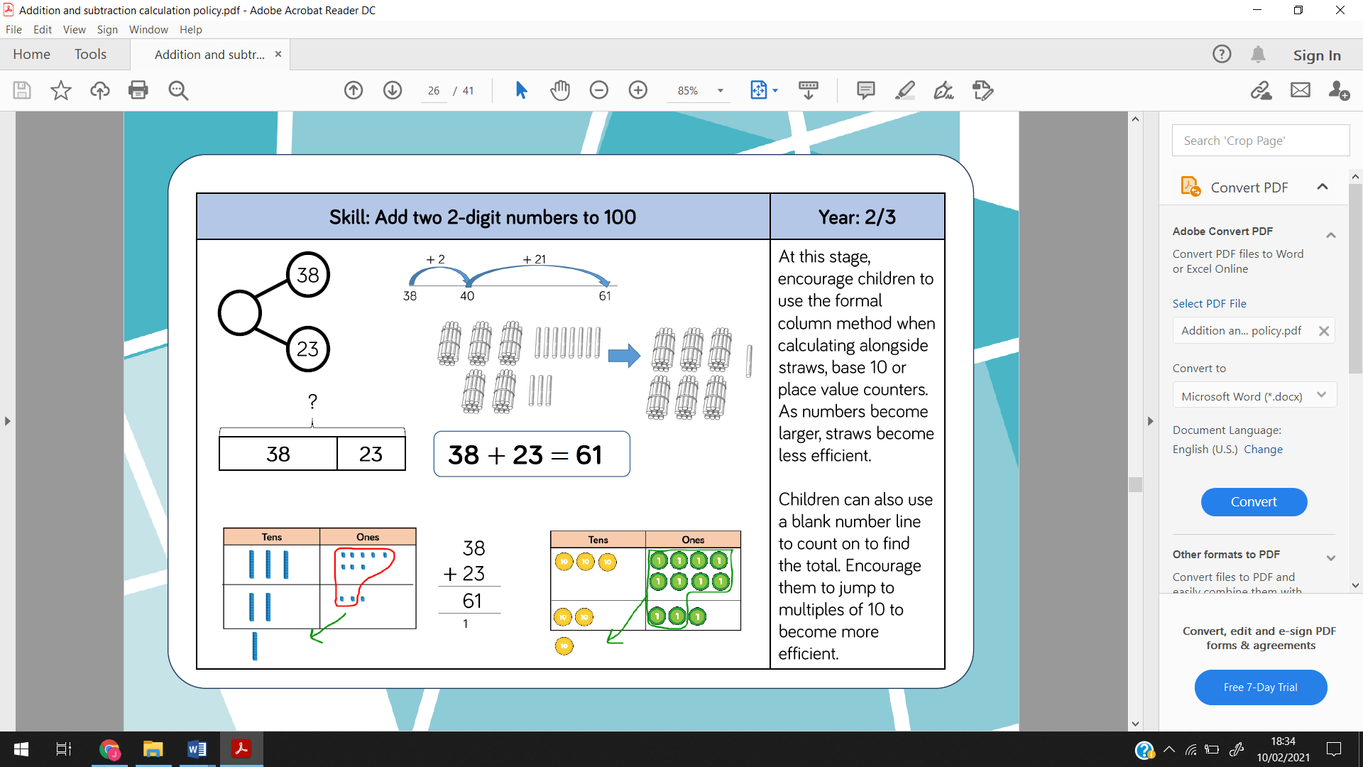  Have the numbers underneath each other, to prepare them for the column method in Y3.  Introduce Y3’s if appropriate but the children MUST fully understand place value and this method first. | 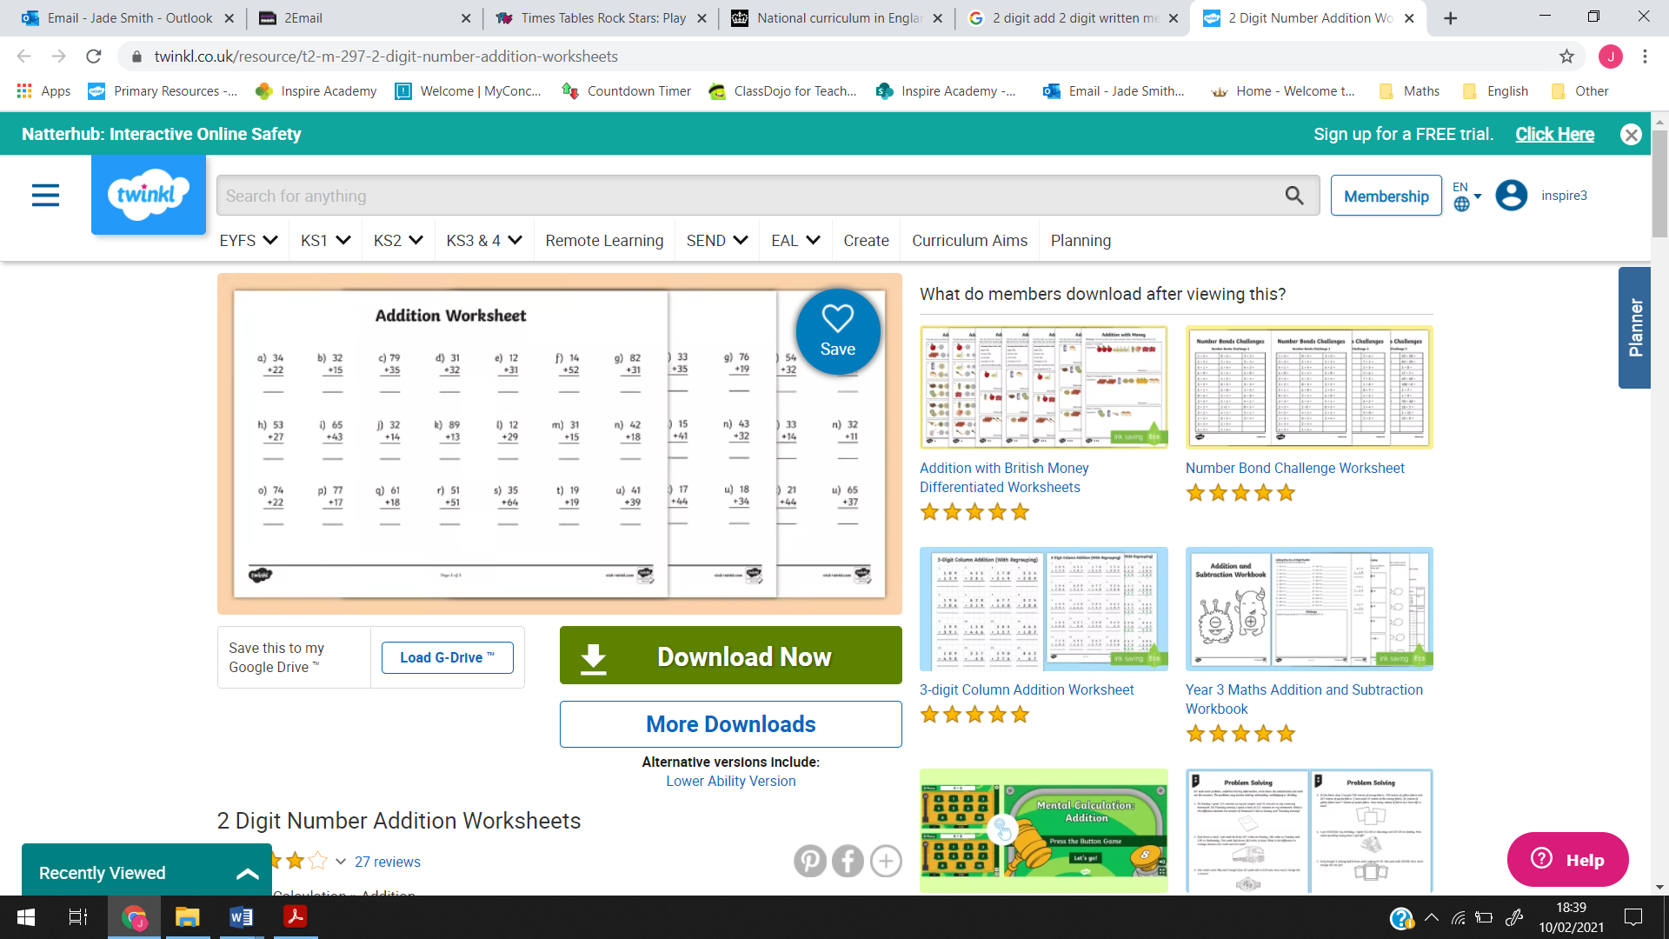  Column method
Add two 2-digit numbers to 100 (with exchange)  Resources  - Base 10  - Place value counters  Have the numbers underneath each other, to prepare them for the written method in Y3. |  | Column method
Add numbers with up to 3 digits  Resources  - Base 10  - Place value counters  Always write the written column method next to the resources, so that they can see the link. |  | Children should be familiar with these methods from Y2….  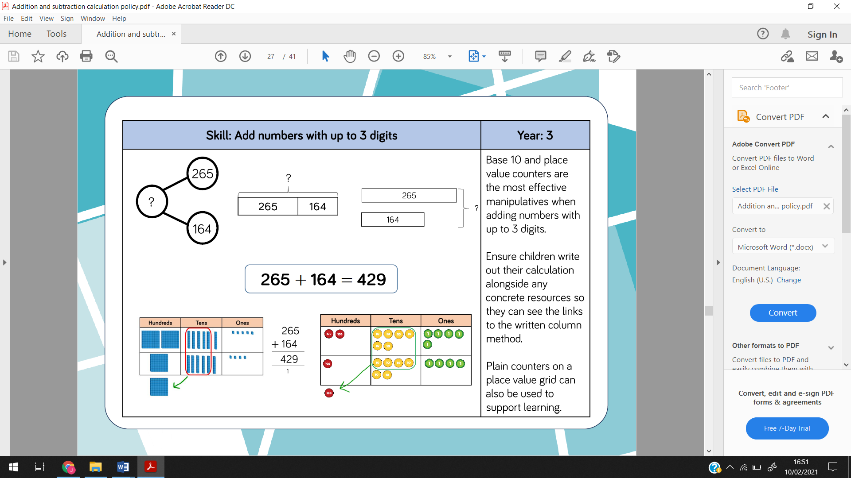  New method for Y3…
Add numbers with up to 4 digits  Resources  - Base 10  - Place value counters  Always write the written column method next to the resources, so that they can see the link. |  |  | Children can still have calculations presented in part whole models or bar models or they use them to support/understand the question but they should be using the written method to work out the answer.  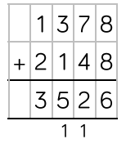  Column method
Add numbers with more than 4 digits  Resources  - Place value counters  Although, they shouldn’t really be needed at this stage. |  |  |  | 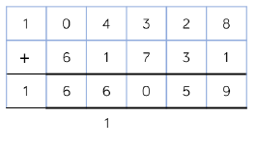  Children can still have calculations presented in part whole models or bar models or they use them to support/understand the question but they should be using the written method to work out the answer.  Column method
Add with up to 3 decimal places  Resources  - Place value counters  Put into context. I.e. money |  |  |  | 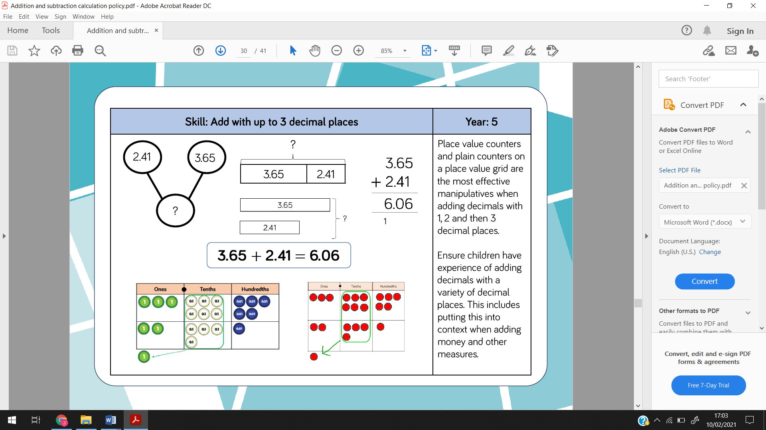  Bar model  Part whole model  Column method

Subtraction
Skill | Year 2 | Year 3 | Year 4 | Year 5 and 6
Subtract 1 and 2 digit numbers to 100 (no exchange)  Resources  - Base 10  - Place value counters  - Straws | Introduce Y3’s if appropriate but the children MUST fully understand place value and this method first. | 55  - 22  ___  Column method
Subtract 1 and 2 digit numbers to 100 (with exchange)  Resources  - Base 10  - Place value counters  - Straws | Crossing the tens out and exchanging them for ones | Column method
Subtract numbers with up to 3 digits  Resources  - Base 10  - Place value counters  Always write the written column method next to the resources, so that they can see the link. |  | Children should be familiar with these methods from Y2…  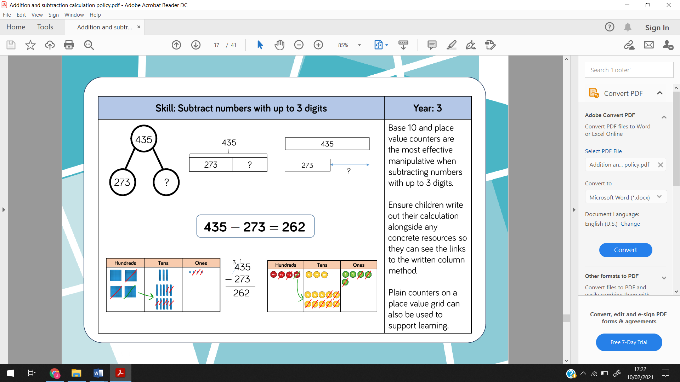  New method for Y3…  Column method
Subtract numbers with up to 4 digits  Resources  - Base 10  - Place value counters  Always write the written column method next to the resources, so that they can see the link. |  |  | Children can still have calculations presented in part whole models or bar models or they use them to support/understand the question but they should be using the written method to work out the answer.  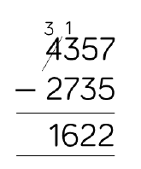  Column method
Subtract numbers with more than 4 digits  Resources  - Place value counters  Although, they shouldn’t really be needed at this stage. |  |  |  | Children can still have calculations presented in part whole models or bar models or they use them to support/understand the question but they should be using the written method to work out the answer.  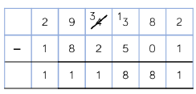  Column method
Subtract with up to 3 decimal places  Resources  - Place value counters  Put into context. I.e. money |  |  |  | 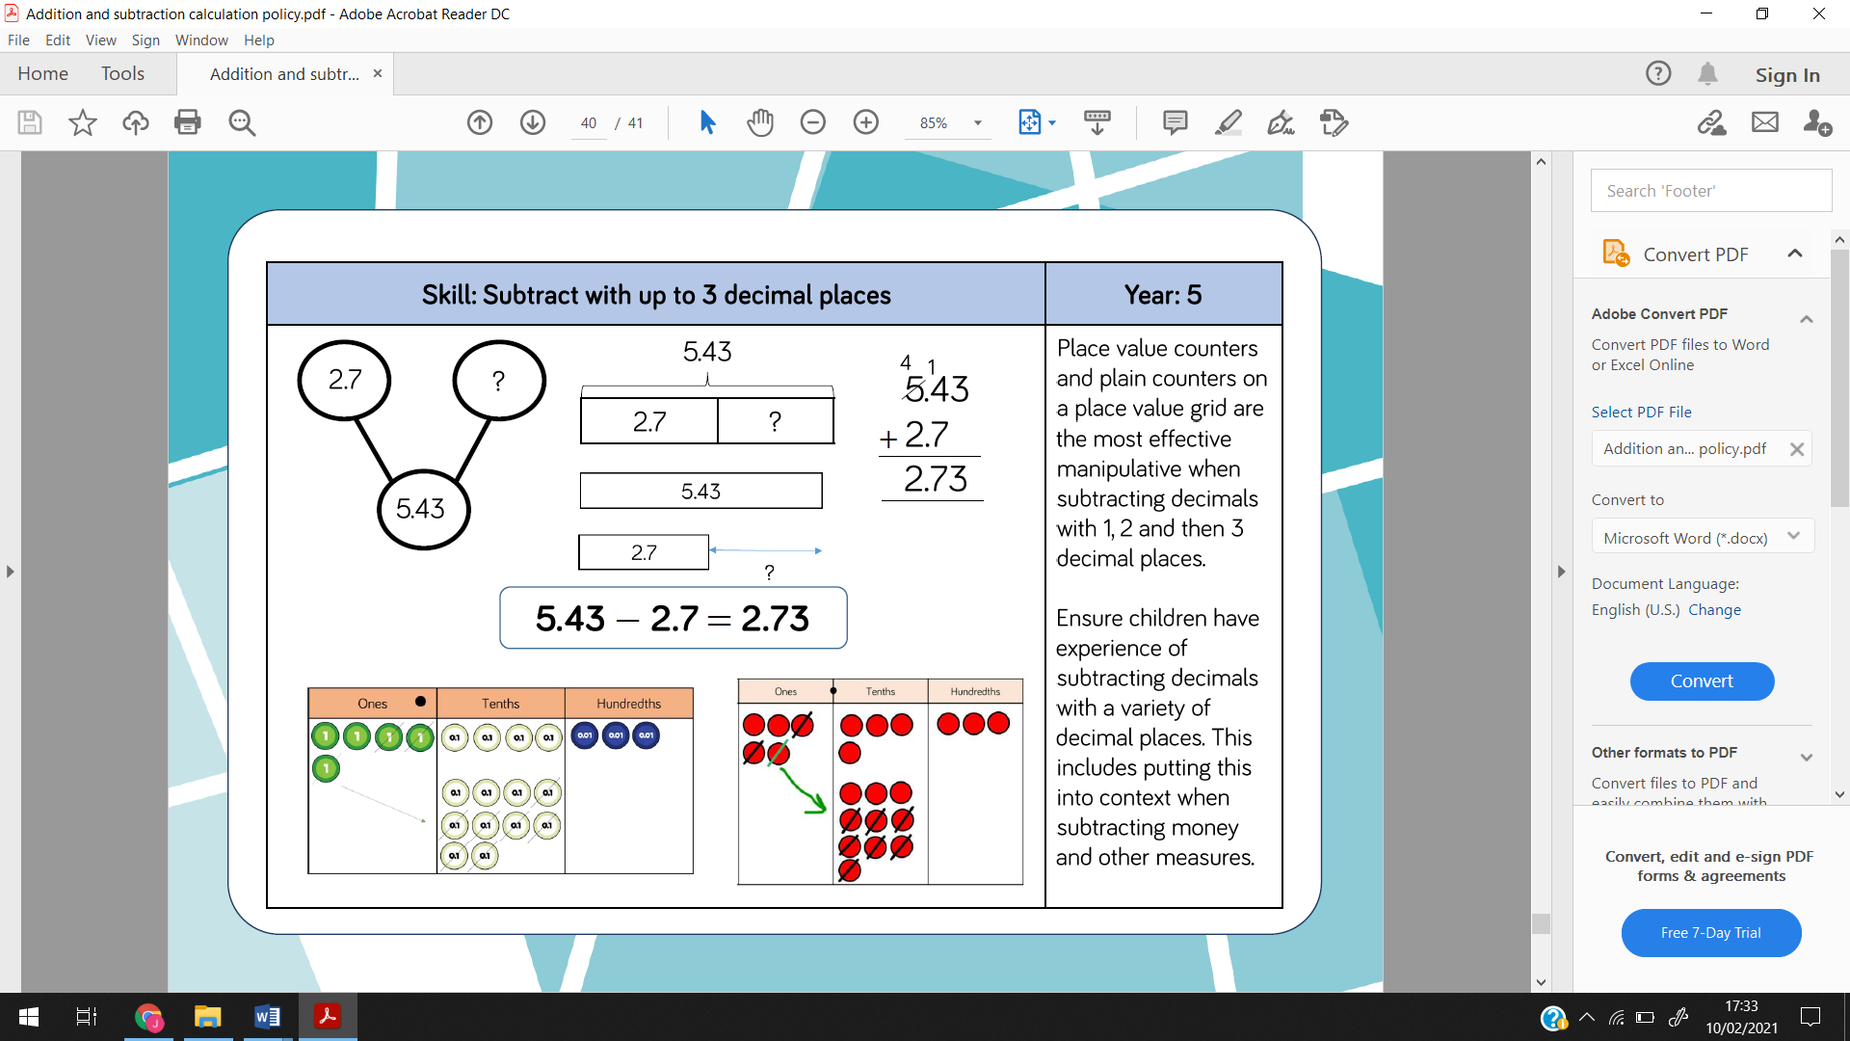  Year 5  Part whole model  Bar model  Column method

