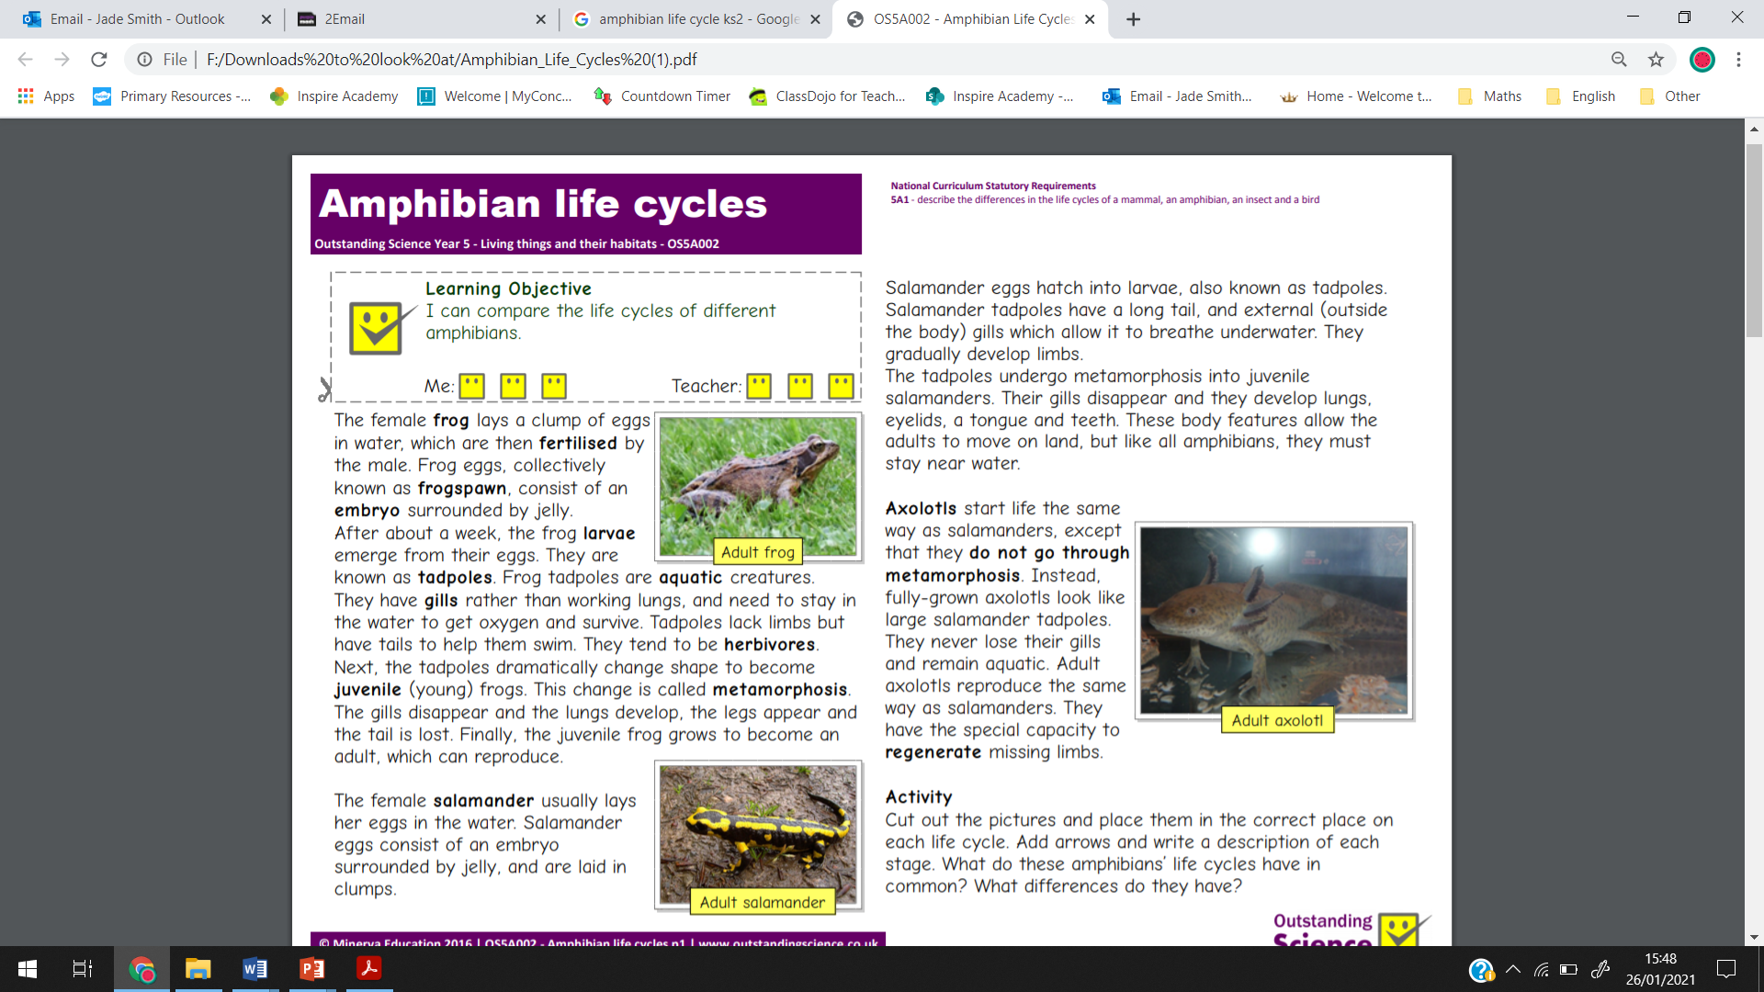

**Activity**

You have 2 minutes to draw a life cycle of one of these animals.