The Battle of Hastings VIPERS Anglo-Saxons
The Battle of Hastings, one of the most legendary battles in English history, was fought between the Saxons and the Normans. It took place in Hastings in the south-east of England and changed the course of English history - forever.
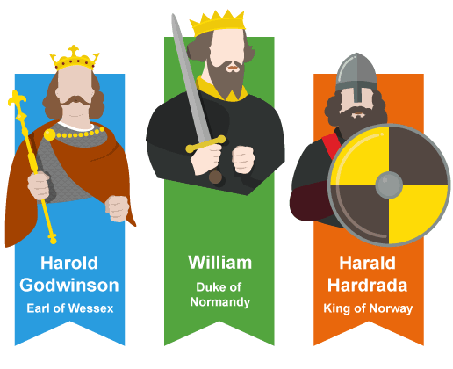
Before the Battle
After the death of the current English king (Edward the Confessor) in 1066, three men were fighting to claim the throne of England: William of Normandy from Normandy, France; Harold Godwinson from England and Harald Hardrada from Norway. On 6th January, one day after Edward’s death, Harold Godwinson was crowned King of England but William and Harald were angry with this decision and prepared to invade England. They both planned to kill King Harold and claim the throne for themselves.
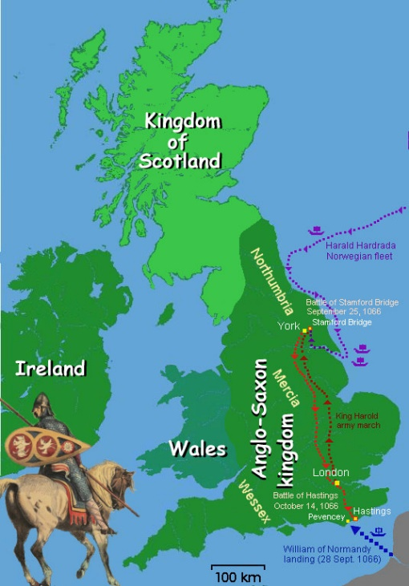
Harald Hardrada invaded first from the north of England on 25th September. However, his army were easily defeated by the Saxons (King Harold’s army) and Hardrada was killed in battle. King Harold was then informed that William of Normandy had landed in the south of England and was attacking the surrounding countryside. As part of the attack, William scorched the earth of the land that was owned by King Harold who was furious and marched his exhausted troops 300 kilometres back towards the south to meet him.
After eight days, Harold and his men reached London where they finally were able to rest. William sent an envoy (messenger) to King Harold asking him to hand over the throne and accept William as the true King of England which he refused and was angered by William’s treacherous demand. Harold was advised to wait before attacking the Normans as his troops were weary and unprepared for a battle as they had suffered some losses fighting Hardrada’s troops and needed time to rebuild. However, Harold ignored this advice and on 13th October, his troops arrived in Hastings ready to fight. Firstly, they captured a hill, now known as Battle Hill, and set up a fortress by forming a shield wall that was surrounded by sharp stakes stuck in a deep ditch. Harold ordered his forces not to leave their fortified positions, no matter what.
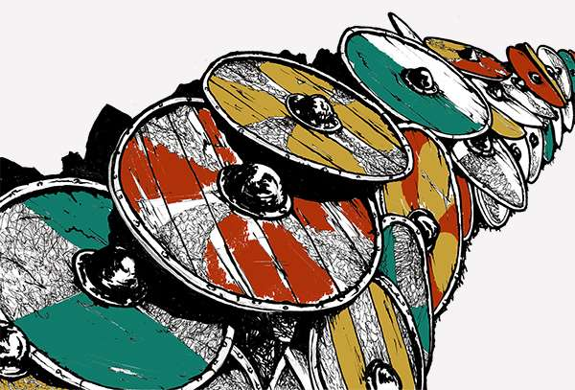
The Battle
On 14th October, the battle commenced. Norman infantry raced up the hill on foot to attack Harold’s army but they were at a disadvantage as it was arduous running up hill and despite their efforts, they could not break the Saxon shield wall. The battle lasted for approximately thirty minutes but William’s forces were cut down and suffered heavy losses. Next, William ordered his cavalry to charge up the hill. They too were unsuccessful and, even though the Saxons lost many men, the Norman’s did not manage to break Harold’s wall.
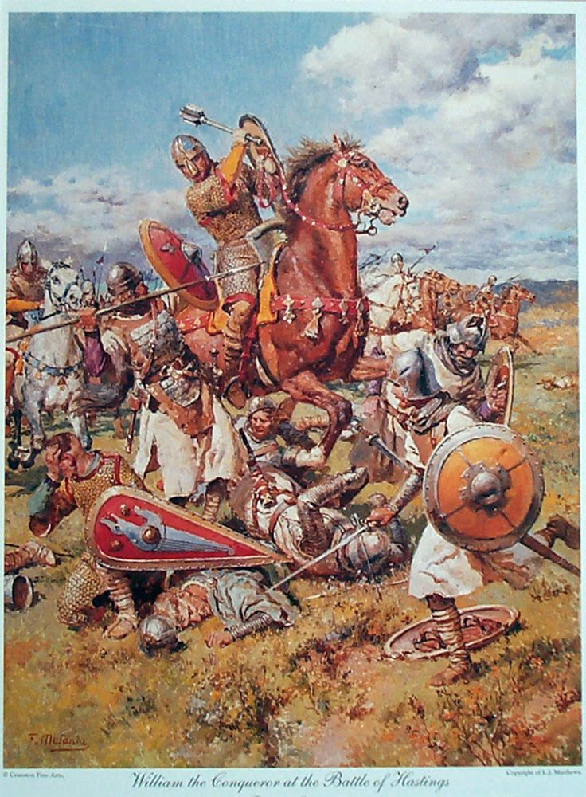
Many hours later, the Normans attacked once again and eventually managed to break through the Saxon shield wall and the two sides fought hand-to-hand. William ordered his best knights to find Harold and kill him. Once they did so, the battle was over and William was victorious. After the battle, William continued his invasion of England and was crowned the new king shortly after. As a result of his success, he is famously known as William the Conqueror.

