Physical Development/ Maths  Which is longer; a second or a minute? Can you compare how many star jumps can you do in 30 seconds to how many you can do in one minute? You could use the stopwatch function on tablet or mobile phone. | Reading  Handa’s Surprise - Click on the link https://www.youtube.com/watch?v=ocnRQi89nK8 and pause the video on the front cover of the book. Can you point to the title of the book? Can you find the Author’s name? What do you think the book might be about?  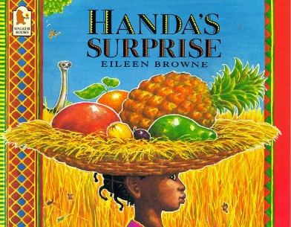 | Using Media And Materials  Can you do an observational drawing of a piece of fruit (ideally a fruit from the story, but any fruit will do)  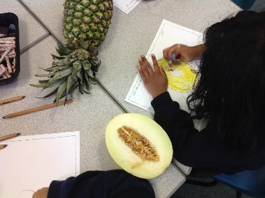  Think about the shape and size of the colours you need.  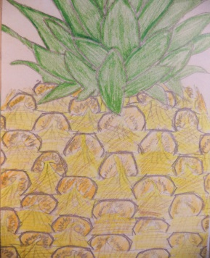
Writing  Can you think of a question you would like to ask Akeyo? Can you write your question?  Use your robot arms to sound out each word and don’t forget your finger spaces. | Phonics  Can you play a game of CVC word bingo?  How many words can you read?  The bingo card is under ‘Learning Grid Documents’. | PSED  Fruit tasting – Can you feel, smell and taste some of the fruits from the Handa’s Surprise story (or any fruit you have available) Can you talk about which fruits you like and any you dislike (if any) ?  