Physical Development  Can you practise your throwing, catching and rolling skills with a ball?  Can you throw the ball in the air and catch it? How many times can you catch the ball without dropping it?  If you don’t have a ball at home you could throw and catch a balloon, a pair of socks, a teddy etc. | Speaking/ PSED  Have a look at the pages taken from the book ‘You Choose’ which is on our Reception home learning page under ‘home learning documents’.  How many different forms of transport can you find? Which ones travel on the ground/in the air/in water?  Where would you travel to? Why? How would you get there? Which form of transport would you choose?  Where would you travel to in the hot air balloon? Why? How would you feel if you landed on the volcano? Or the desert island?  Who would you take on your adventure with you? | Using Media And Materials  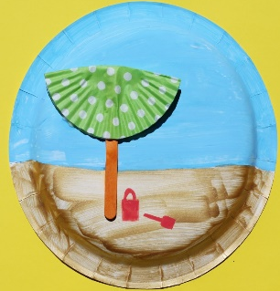  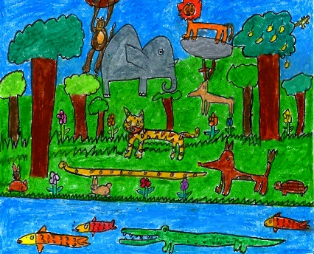  If you could travel anywhere, where would you go? Can you draw/ create a scene of what you might see there?
Maths  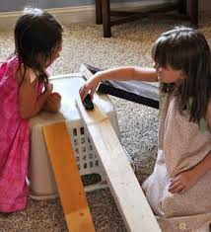  How far can your toy cars/vehicles travel? Maybe you could set up a ramp using a book or piece of wood and then push your cards down and see which goes the furthest?  Can you measure to see which goes the furthest? Maybe use a measuring tape or mark some lines on the ground. | Phonics  Can you practise reading and writing the tricky words we have learnt so far? You could practise writing them in shaving foam, a tray of rice, on paper, on a whiteboard, using tweezers and pom poms etc.  into  the  no  I  to  go  he | Writing  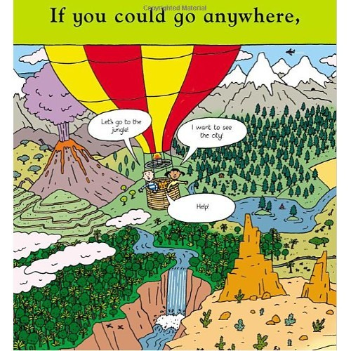  After discussing where you would choose to travel to, can you write a sentence about where you would go to and how you would get there?  For example: I would go to the moon on a rocket  Use your robot arms to segment the sounds you can hear in each word. Remember to leave a finger space between each word.

