Literacy  Think of our story ‘The Train Ride’. You should now have some actions for the story. Can you act out the story, doing the actions and join in with the repeated refrains?  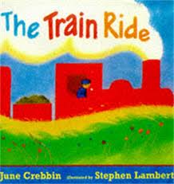 | Maths  This week we will be separating a group of objects (up to 5) in different ways, beginning to recognise that the total is the same.  Can you do this at home with a group of your toys?  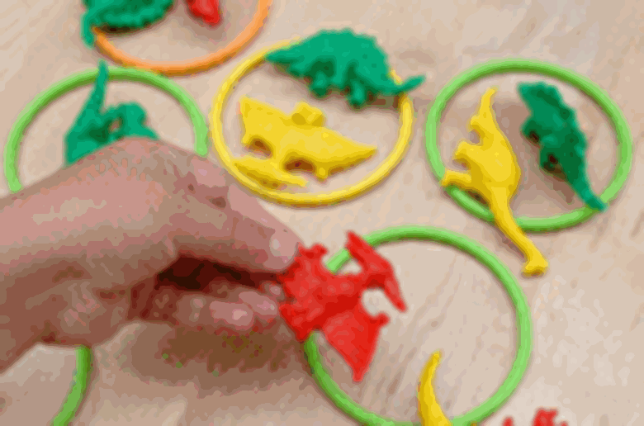 | Phonics  This week, we are looking at initial sounds. Can you play ‘I spy with my little eye, something beginning with a, b, c, d… etc. Can your child identify what you are looking at around the room?
Health and Self Care  Can you practise getting dressed all by yourself? You may need a little help with some tricky items of clothing. | Physical Development  Can you walk downstairs, two feet to each step while carryin a small object?  Make it fun, dress up in your favourite costume! | Listening and Attention  Can you play Simon Says? Listen carefully and only do the actions that SIMON tells you to do.  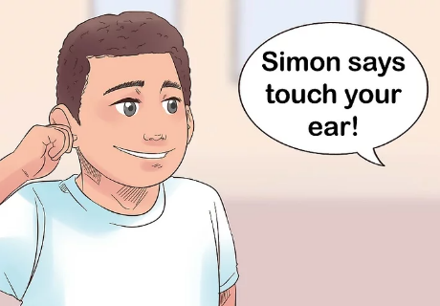
Useful links
- https://www.purplemash.com/sch/inspireacademy
- https://www.topmarks.co.uk/maths-games/3-5-years/counting
- https://www.bbc.co.uk/teach/school-radio/nursery-rhymes-a-to-z-index/z4ddgwx
- https://new.phonicsplay.co.uk/resources/phase/1

Nursery’s Home Learning- Week commencing 8th February – Topic - Transport
Set yourself a challenge- How many of these learning challenged can you complete?

