Handwriting  Practise writing your full name. Remember to warm your hands up before you start. You could use one of the videos we’ve used in previous weeks, or you could make up your own warm up!  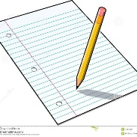 | Music  Can you watch a musical film?  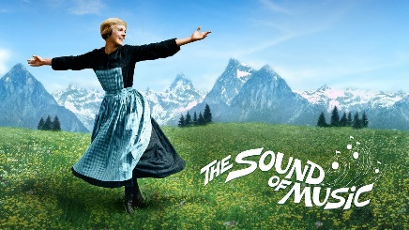 | Science  Animals including Humans  Watch the video on our class page. We’re starting a new area of learning all about animals including humans.  This week, we’ll be using our ideas and observations to suggest answers to questions.  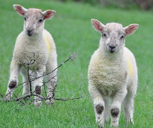 | Spellings  Here are our class spellings for this week.  table apple  bottle little  middle able  wobble multiple  dazzle riddle  Please see the video on out class age for Friday’s spelling test.  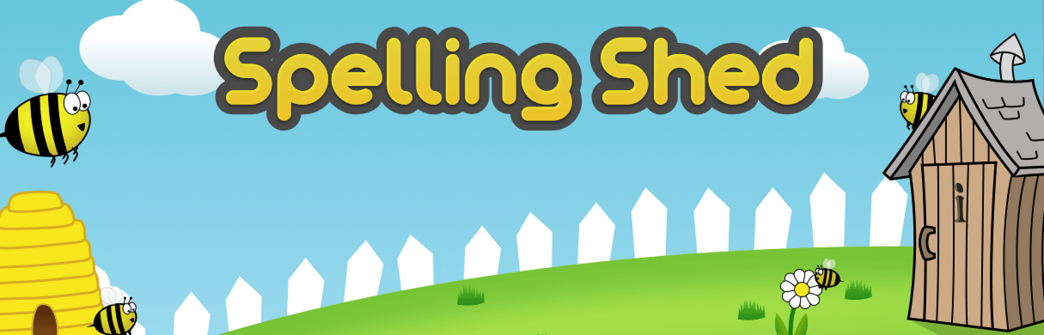
PE  Join the children in school in completing the Joe Wicks fitness videos every Monday, Wednesday and Friday morning at 9am.  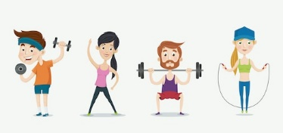  Challenge: Join in with Get Fit February! You’ll find the timetable on our class page. Good luck! | Geography  Can you remember the name of the 7 continents? Could you make some playdough at home and then create a playdough map of the 7 continents?  Playdough recipe - https://www.bbcgoodfood.com/howto/guide/playdough-recipe  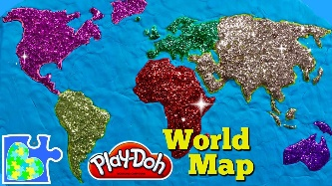 | PSHE  Celebrating Difference  Think about:  - Are there any similarities between what boys and girls like/dislike?  - Are there always differences?  - Can you think of some similarities between boys and girls?  Using the shield template on our class page, can you design a similarity shield with four things inside that you and a friend of the opposite sex have in common? You might choose things such as ‘we both have brown hair’ or ‘we both love to draw and colour’.
Links
Geography - https://www.youtube.com/watch?v=K6DSMZ8b3LE

Year 2’s Home Learning- Week commencing 22nd January

