World Book Day  We’re celebrating World Book Day on Thursday 4th March. We’d love for you to login to Google Classroom to join us for a story. We can’t wait to see you! | Music  Learn to sing a new song.  You could listen to some of our Out of the Ark assembly songs and choose your favourite one to practise and perform for your family at home! | Science  Animals including Humans  What do you need to survive?  Think about the following question:  If you were stranded on a desert island, what things would you like to have with you?  Then, watch this video to find out more about our basic needs.  What do humans need to stay healthy? - BBC Bitesize  Make two separate lists.  ‘Things I need to survive’ and ‘Things I need for happiness/comfort’. | Spellings  Here are our class spellings for this week.  camel tunnel  squirrel travel  towel tinsel  bagel hazel  vowel jewel  Please see the video on out class age for Friday’s spelling test.  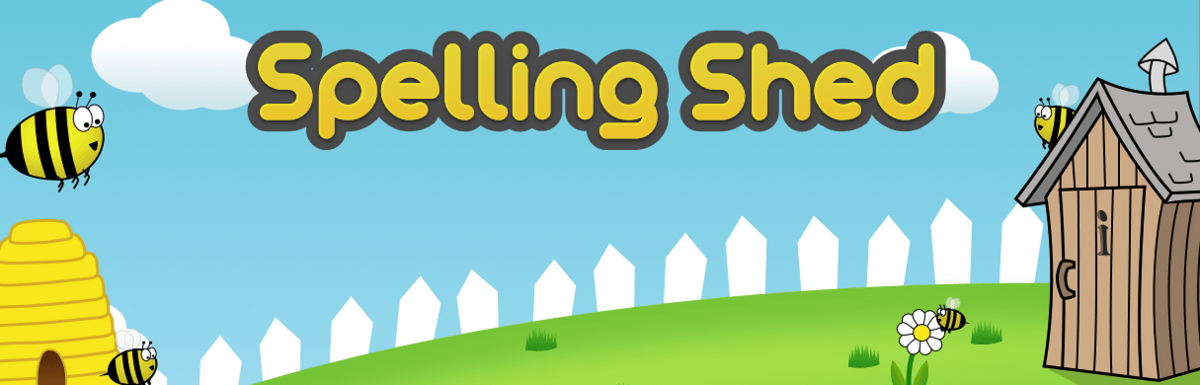
PE  Join the children in school in completing the Joe Wicks fitness videos every Monday, Wednesday and Friday morning at 9am.  Challenge: create a 10 minute workout for your family to follow. | History  What is an explorer?  Can you draw a picture of what you think an explorer looks like? You could label them with your ideas.  This week, we are learning about an explorer called Christopher Columbus.  https://youtu.be/Qt7IiKuYMBY Watch this video to find out about him. You could research some more facts about him after.  Draw or write a list of objects that you think Columbus would have taken with him on his journey. | R.E  Easter – The Resurrection  If you are comfortable to, share a personal example of a person or a pet you have lost. How do you help yourself remember them? How do you make yourself feel better when you feel sad about losing them?  Write down a happy memory about a person or animal that you don’t see anymore. It could be because they have passed away or because they’ve moved house, schools etc. | Time for YOU!  On Monday 8th March we’ll finally all be back in school together! We’re so excited to see you all.  If you’re slightly worried about coming back to school, don’t be! Once you come into school on that first day back, it’ll be like you’ve never been away. If you’re worried, spend sometime this week talking to your grown-ups at home. Discuss your worries and watch them shrink and go away!
Year 2’s Home Learning- Week commencing 1st March

