French  Year 4’s Home Learning – 8th – 12th February 2021  Complete all the activities below, one per day. Post on twitter or send me your work via email.  (Video on school website) | Art / DT  LC: - Can I design from a plan?  (Look at info below.) | History  LC: - Can I research Town name origins?  So Tameside is clearly named after being set either side of the River Tame. But what about the 9 towns of the borough? Plus, research areas too e.g. Hurst Cross, Ladysmith, Cockbrook etc. | PHSE  LC: - Can I recognise how democracy and having a voice can help a community?  Why do we have a school council? How do the council help the school community?  What other benefits can you think of having a council?  Write a letter of application as though you were applying for the School Council.  Explain the above questions and why you think you would be good for the job.
Science  LC: - Can I present the Water Cycle?  Your task is simple – Show the Water Cycle, in a box.  See the images below for some ideas.  You should label each process too (Evaporation and condensation)  Tweet your final work or bring in to school, it would be amazing to display some of these! | RE  LC: - Can I explain about Judaism?  Consider your learning through the last few weeks and perhaps other research you could do about Judaism.  Present a leaflet which explains elements of the Jewish faith. This can be done on Word and emailed in so we can use them for your floorbooks!  Look below for some ideas. | PE  LC - Can I balance like an ambidextrous stork?  Watch the video and time yourself on either leg. Remember your non-supporting leg MUST be at a right-angle. Is one leg much stronger than the other? Or are you ambidextrous?  Good Luck.  https://www.youtube.com/watch?v=aDxT-56hGL0 | Music  LC:- Can I create a feel good playlist?  Thinking about the theme, can you create a playlist of feel good songs, that make you feel encouraged and proud to be you!  Post your list on Twitter for all to share and explain why certain songs make you feel good and proud to be you!

Useful links
- https://www.inspireacademy.org (School website where Video Learning and Home Learning Pack can be accessed)
- SPELLINGS – These have been updated and challenges set on Edshed / Spellingshed. CAN YOU COMPLETE 20 CHALLENGES?

SCIENCE:
ART:
Start an ideas / sketch book!
Imagine you are a mill worker. What clothes would you wear? What materials would they be made of? Why would you have certain clothes (eg cap / style of trousers)
Find the answers to these questions, and note them in your sketch book.
You have been asked by a wealthy mill owner to improve the clothes of the workers.
Make notes to suggest HOW you might change the clothes. Remember only limited types of material were available in the 1800’s and early 1900’s
Draw pictures / print images from the internet and make notes next to them
Explain why these improvements would make the clothing better. Comfort / working conditions / weather?
You will continue this task next week and design your new outfit, sketching each individual piece.
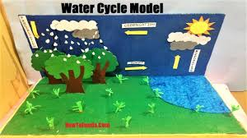

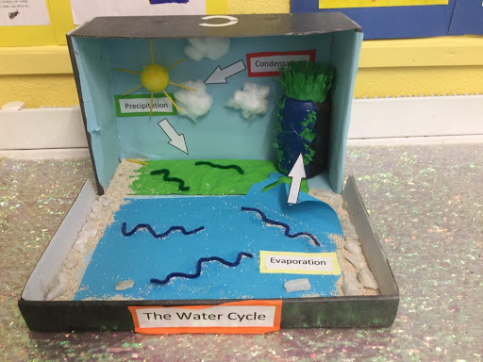

RE: Kosher Foods
Seder Meal
Exodus Story
Passover

