French  Year 4’s Home Learning – 1st – 5th March 2021  Complete all the activities below. Post on twitter or send me your work via email.  (Video on school website) | Art / DT  LC: - Can I make Anglo-Saxon bread?  (Please see sheets from Home Learning Pack for this activity) | History  LC:- Can I match the punishments?  See worksheet and Power Point Presentation. | PE  LC: - Can I play Hopscotch?  See information and photo below.
Science  LC: - Can I identify electrical dangers around the home?  http://www.switchedonkids.org.uk/electrical-safety-in-your-home  Play the game above to help you recognise dangers in the home.  THEN, watch the following link:  http://www.bbc.co.uk/education/clips/zyxd7ty  Produce a poster to show some of the main electrical dangers in the home / warn others of dangers. There are some examples below. | RE  LC: Is forgiveness always possible for Christians?  Can you brainstorm your knowledge and perceptions of Jesus? Do you think he had enemies? Explore why Jesus had enemies and was arrested. You could imagine yourself as someone who betrayed Jesus, like Judas or Peter. Maybe produce a piece of drama where you explain their actions and feelings.  Watch the links below and think about Jesus’ response and did he forgive them? | PHSE  LC: - Can I understand what racism is?  Racism is discrimination or a negative judgement about someone due to the colour of their skin or their race and might include their beliefs or religion. All forms of racism are unacceptable!  Can you design a ribbon to show we need to fight racism? You will find a ribbon template in your learning pack. It can include slogans, words, pictures as appropriate. Perhaps you will choose a certain colour, or a mix of colours to get your message across. | Music  LC:- Can I compare versions of the same song?  When an artist re-records somebody else’s song, it’s called a cover version. There are thousands of examples in Pop Music.  Find at least 3 cover versions of Lean on Me by Bill Withers.  https://secondhandsongs.com/performance/2983  Use the above link for help if you are struggling!  Compare each version. Look at the prompts below.

Useful links
- https://www.inspireacademy.org (School website where Video Learning and Home Learning Pack can be accessed)
- SPELLINGS – These have been updated and challenges set on Edshed / Spellingshed. CAN YOU COMPLETE 20 CHALLENGES?
- RE - www.bbc.co.uk/education/clips/z8vcd2p www.bbc.co.uk/education/clips/zrfgkqt

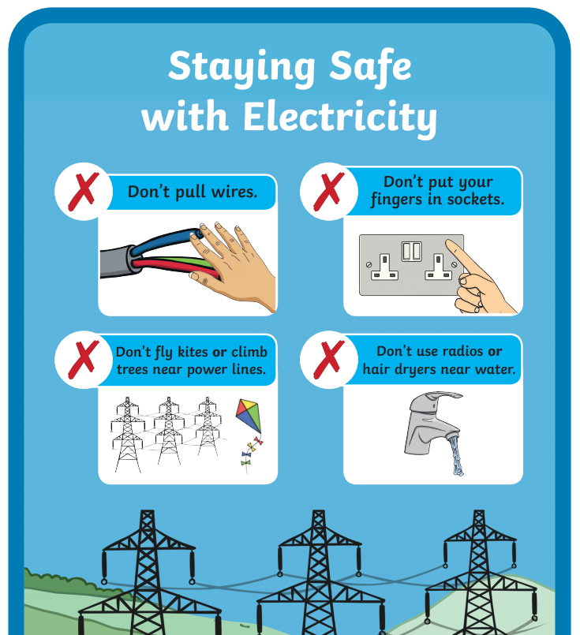
SCIENCE:

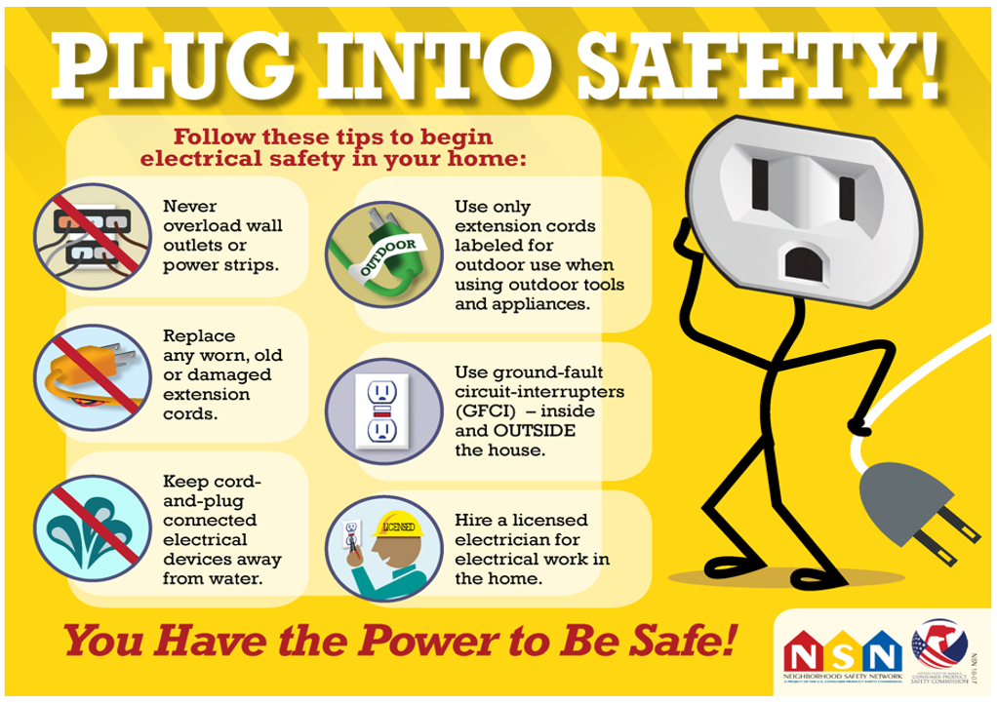

MUSIC:
What genre / style is each cover version? (Gospel, Pop, Jazz, Reggae, etc…)
How is it different to the original?
Are there any instruments used on other versions that are not on the original? Why do you think this is?
Why do you think the song has been covered over 100 times?
Is it always a Male Voice that leads the other versions?
Do you notice anything about the PITCH of the vocals if a female sings the song? Why do you think this is?

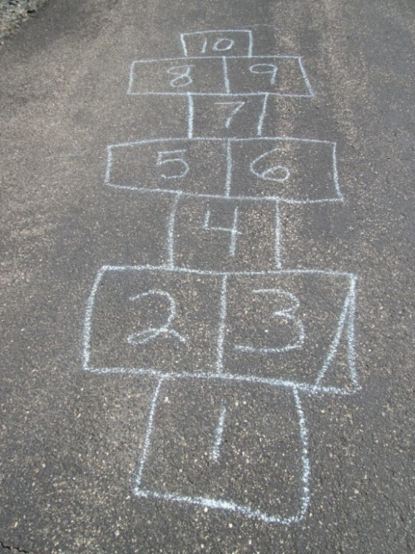
KS2 PE Challenge Week Beginning Monday 1st March
Hopscotch – Great for balance and a plyometric activity.
Can you create one that goes up to 20?

