Guided Reading

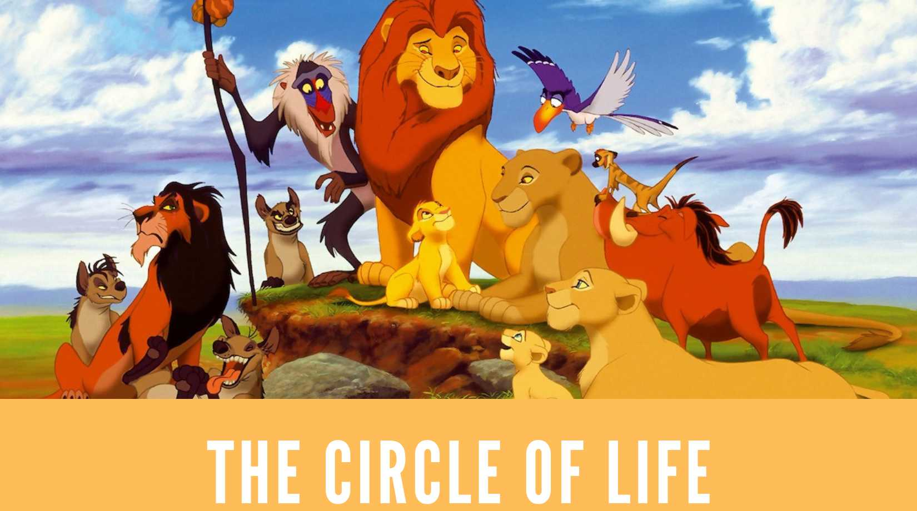
https://www.youtube.com/watch?v=JuAzr32kFRo

Name……………………………………………………………..
Week beginning……………………………………………..

Nants ingonyama bagithi baba
Sithi uhm ingonyama
Nants ingonyama bagithi baba
Sithi uhhmm ingonyama
Ingonyama
Siyo Nqoba
Ingonyama
Ingonyama nengw' enamabala
Ingonyama nengw' enamabala
Ingonyama nengw' enamabala
Ingonyama nengw' enamabala
Ingonyama nengw' enamabala
Ingonyama nengw' enamabala (se-to-kwa!)
Ingonyama nengw' enamabala (asana)
Ingonyama nengw' enamabala (se-to-kwa!)
Ingonyama nengw' enamabala (se-to-kwa!)
From the day we arrive on the planet
And, blinking, step into the sun
There's more to see than can ever be seen
More to do than can ever be done
There's far too much to take in here
More to find than can ever be found
But the sun rolling high
Through the sapphire sky
Keeps great and small on the endless round
It's the circle of life
And it moves us all
Through despair and hope
Through faith and love
'Til we find our place
On the path unwinding
In the circle
The circle of life
Ingonyama nengw' enamabala
Ingonyama nengw' enamabala
Ingonyama nengw' enamabala (se-to-kwa!)
Ingonyama nengw' enamabala (se-to-kwa!)
Ingonyama nengw' enamabala (se-to-kwa!)
Ingonyama nengw' enamabala (se-to-kwa!)
Ingonyama nengw' enamabala (se-to-kwa!)
Ingonyama nengw' enamabala (se-to-kwa!)
Ingonyama nengw' enamabala (se-to-kwa!)
Ingonyama nengw' enamabala (se-to-kwa!)
Ingonyama nengw' enamabala (se-to-kwa!)
Ingonyama nengw' enamabala (se-to-kwa!)
Ingonyama nengw' enamabala (se-to-kwa!)
Ingonyama nengw' enamabala (se-to-kwa!)
Ingonyama nengw' enamabala (se-to-kwa!)
Ingonyama nengw' enamabala (se-to-kwa!)
It's the circle of life
And it moves us all
Through despair and hope
Through faith and love
'Til we find our place
On the path unwinding
In the circle
The circle of life

V I P E R S

- Complete the sentence.

From the day we arrive on…
the planet the clouds

the sun the stars

- It’s the circle of life – Can you explain the meaning of this?
…………………………………………………………………………………………………………………………
……………………………………………………………………………………………………………

- Find a word in the chorus that means the same as ‘to lose hope.’
……………………………………………………………………………………………………………………………
……………………………………………………………………………………………………………………………

- What’s the meaning of the word ‘unwinding?’
……………………………………………………………………………………………………………………………
……………………………………………………………………………………………………………………………

- The circle of life refer to…
Circle the correct answer/s

Love Faith Happiness Calm Hope Despair Joy Anger Sadness

