Year 1 Home Learning Grid – Week Commencing 4 January 2021

Maths – Money  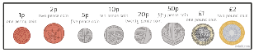  - Can you get a variety of coins and put them in order from the smallest value to the largest? You could then use wax crayons or a pencil to do some coin rubbings.  - Can you label up some of your toys with price tags e.g. 5p, 7p, 12p and play shops?  - Can you get a selection of 2p coins, 5p coins and 10p coins and use them to help you practice counting in 2s, 5s and 10s (links to dance videos for counting in 2s, 5s and 10s below).  - Can you play the online game here: https://www.topmarks.co.uk/money/coins-game | English – Sentences including Adjectives  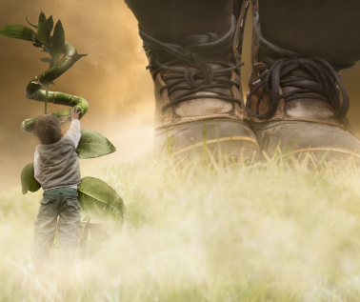  - Can you write a sentence about this image, including some interesting adjectives (describing words)? Remember your capital letter, fingers spaces and full stop. | Science – Seasons (Winter)  - Watch this video Seasonal change in the countryside - KS1 Science - BBC Bitesize  - Can you name the four seasons? What season are we currently in? How do you know? What is the weather like? What clothes do we wear in this season?  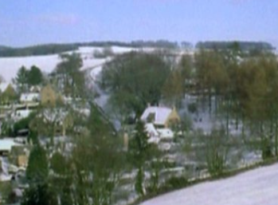  - Could you go on a walk around your local area and have a look for signs of winter? What did you see, hear, smell and what could you touch? Did you spot any wildlife? We’d love you to tweet a photo of your walk! | Just for fun…  In Music this week we were going to be appraising Blues music, in particular, How Blue Can You Get by BB King. You could have a listen to this and think about whether you like this style of music or not, how it makes you feel, what kind of dance moves would go with this music, what instruments you can hear, how you would describe the music and singing etc.  If you are still in the mood for dancing, why not search on YouTube for a Go Noodle dance video that we love to do in class between lessons.
Computing  - This week in Computing we were going to be learning the basics of using a laptop. If you have a laptop at home you could watch your family log on to, and shut down the laptop then have a go yourself.  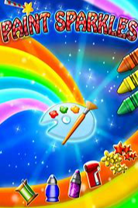  - We were also going to be exploring the free app, Paint Sparkles, an online colouring app, as practice for our work later this term on creating our own online illustration. | Design Technology  This term’s topic is all about food.  - Can you get a selection of food from your cupboards and sort it into two boxes – healthy and unhealthy. Are there are any items that are a bit of both – have a chat with your family about this?  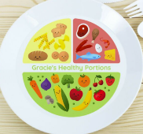  - Can you create a healthy eating plate – draw a circle on some paper and either draw pictures or cut and stick from old magazines to show lots of healthy foods that you like to eat. | History  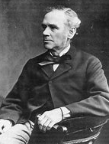  - In History this week we were learning about a significant individual from the past from our local area; Mill Owner, Hugh Mason. Please explore ideas on how to become historians and find out about him, such as asking Siri, asking Alexa, or searching on Google. Could you try one of these methods to see if you can find out 3 things about Hugh Mason? – you could tell your family what you find out verbally or write your findings down.
Maths Links – Counting in 2s, 5s and 10s: https://www.youtube.com/watch?v=OCxvNtrcDIs / The Counting by Fives Song / Counting Songs | Scratch Garden - YouTube / Count Together by 10's | Counting Workout for Kids | Jack Hartmann Counting by 10s - YouTube

