Year 1 Home Learning Grid – Week Commencing 11 January 2021

Maths – Place Value to 20  - Can you write the numbers 1 to 20 in order? Can you ask someone in your family to write the numbers with some missing so you have to fill in the missing numbers?  - Pick a teen number. Can you say what is one less and one more than this number e.g. if I pick 15, one more than 15 is 16 and one less than 15 is 14. Once you have picked your number can you use some objects to help you work out different ways of making your chosen teen number e.g. I could make 15 by having 3 lots of 5 or 10 and 5 or 14 and 1 etc.  - Can you have a go at this fun online game to practise place value Place Value Basketball - Dienes Game for 5 to 8 Year Olds (topmarks.co.uk) | English – Sentence Writing  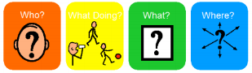  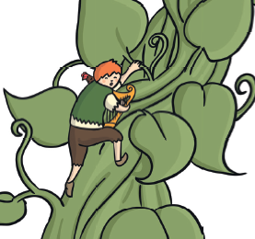  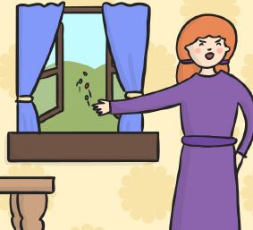  - Can you write some sentences about the images below, including who, doing what and where? Remember your capital letters, fingers spaces and full stops. | Science – Seasons  - In the season of winter what do you notice about when it is dark and when it is light? In winter the sun rises much later and sets much earlier than in summer so we only have a short time of daylight each day in the current season.  - Here is a video explaining how the Earth gets its daylight The Sun - day and night - KS1 Science - BBC Bitesize  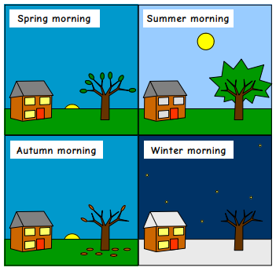 | Just for fun…  In PE, we had recently started to learn about hockey. Here is a short video as a recap:  Today's Thing: Hockey | CBC Kids - Bing video  If you are out on a walk at the park you could always make an improvised game of hockey using a stick and a small ball! Other ways of getting in your physical activity include:  Cosmic Yoga  Cosmic Kids Yoga - YouTube  Disney Workouts  Break a Sweat With These Disney-Inspired Workouts | Disney Family  Andy’s Wild Workouts  CBeebies - Andy's Wild Workouts (bbc.co.uk)  Or you could just have a fun disco with your family!
Computing  - There are some lovely activities separated by age available at Home Learning (barefootcomputing.org)  - You could also log in to Purple Mash and explore any activities that you like.  - You could practise drawing and paint on Art – 2Paint  - You could practise programming algorithms on Computing – 2Go  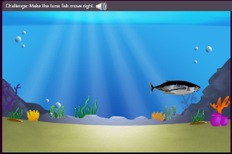  - You could practise coding on Computing – 2Code – Fun with Fish | Design Technology  - This week we were going to be learning where food came from. There are some short videos about this via this link: Videos - Food A Fact Of Life Can you talk to your family or search online or use any books you have to work out and match up where each food comes from  Cow Bacon  Pig Chips  Wheat Milk  Potatoes Ketchup  Chicken Bread  Tomatoes Eggs | History  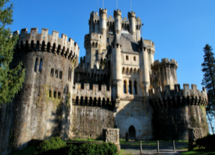  This week we start our topic on castles. Here is a video to watch: https://www.bbc.co.uk/education/clips/zqr4d2p  - Can you search online or in your books for some pictures of castles and find out what the features are called? Find out which part of the castle is the turret, drawbridge, battlements, moat, portcullis, dungeon and keep?  - Think of ways you could represent a castle including the above features – you could draw, paint, make out of old cardboard or blocks / lego. We would love to see your photos on Twitter!
Phonics: Phase 3 on Help A Hedgehog (ictgames.com)

