Science- Mammal’s life cycle (45 minutes)  Year 5’s Home Learning- Week commencing 25th January 2021  Complete one or two activities per day from the learning grid.  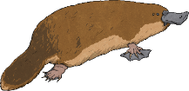  Look at the PP and watch https://www.youtube.com/watch?v=sz3Yv3On4lE to learn about the different types of mammals.  Choose a type of mammal that you would like to research (Placental, monotremes and marsupials).  Write down facts about what makes these animals a mammal (different to an insect or a bird) and about their life cycle.  For example,  Monotremes  Their young hatch from eggs, which is similar to a bird. However, monotremes also produce milk for their young, which makes them mammals and not birds. | Art- The tin forest animals (45 minutes)  Using your drawing from last week as a practise, draw it again onto a thick piece of card (cereal box or a delivery box would be perfect).  Using PVA glue, carefully place a thick layer of glue over your drawing and leave it somewhere safe to dry.  https://www.youtube.com/watch?v=I406Ab_HjM8  If you haven’t got any glue, don’t worry! Why don’t you colour or paint your picture. Think about it, do you want it to look like it’s made out of metal and use greys and blacks or do you want it to look like the end of the story and colourful. | 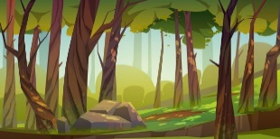  Geography- Deforestation  (1 hour)  Look at the PP and watch https://www.youtube.com/watch?v=oA10-oZi4Xc To learn about deforestation.  Task- Create a poster to support your view. Do you think deforestation is a good thing or that it is a bad thing and we need to help stop it from happening?  Don’t forget to make them nice and colourful, add pictures and most importantly, include the facts that you have learnt.  Challenge- what small things could you do to help stop deforestation? This could be at home or when you return to school. E.g. don’t waste paper.
RE-Are Sikh stories important today? (45 minutes)  Are Sikh stories important today?  Do you remember learning the story, ‘The birth of the Khalsa?’ The themes of this story are courage and standing up for what you believe in.  Activity- Can you write how courage and standing up for what you believe in is still relevant today to Sikhs/non-  Sikhs?  Use this link to help https://www.youtube.com/watch?v=eO_6AIjM3Rc | Music- (30 minutes)  Think about the Message of a song Listen to a variety of Pop Ballads. Some examples are on here… https://www.youtube.com/watch?v=uQWUOjo7a94  What do you notice about the Pulse, Tempo, Instruments, Dynamics and Vocal Performance (inc Lyrics)? Why are they similar in their characteristics / musicality? What messages do most Pop Ballads want to convey?  Challenge – Can you make a link between the dynamic changes and the lyrics at specific points in a Pop Ballad? | PE- LC:- Can I improve flexibility, muscle strength and focus?  Yoga is a perfect way to improve all these. Here are a couple of options. Aim for 3 sessions this week.  - Cosmic Kids Yoga  - Yoga for Beginners with Adriene
PSHE- (30 minutes  Can you think of different types of rewards?  Think about any that are not material rewards  e.g. ‘being told well-done’, a smile, a hug.  Then complete the sentence:  ‘The reward I would most like to receive is...’ (e.g. a trophy, certificate, hug, etc.).  Think about the six rights and the responsibility  you did last week. For each right and  responsibility can you think of an appropriate  reward if children are seen to be upholding  that right? How about a consequence if  children were not showing responsible behaviour  and the right was being ignored? | French- Can you read and say 4 face part nouns in French? (30 minutes)  Watch the video and follow along.  https://www.youtube.com/watch?v=R4iAPx8KRPw&feature=youtu.be  Task- draw an alien’s face and label the different parts. Can you write the number of each part too?  How many eyes will it have? Will it have an odd number of ears? You can choose!  Challenge- colour them in and add the colour to your labels. | Computing- We are cryptographers  How did people used to communicate before we had phones and the internet?  Using the PP, learn all about semaphore communication. Watch the video to help you learn the different signals.  https://www.youtube.com/watch?v=LlRJQd5vmX0  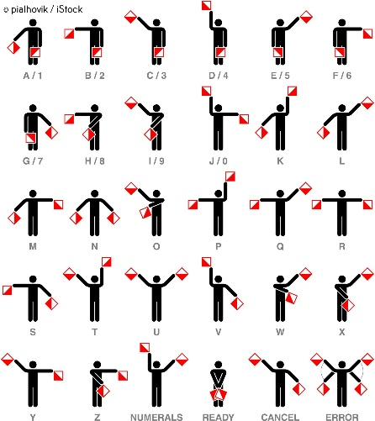  Task- Can you send a message using semaphore communication?  You could try to send it to someone you live with or record it and email it to us. We will try and guess what you are telling us.

