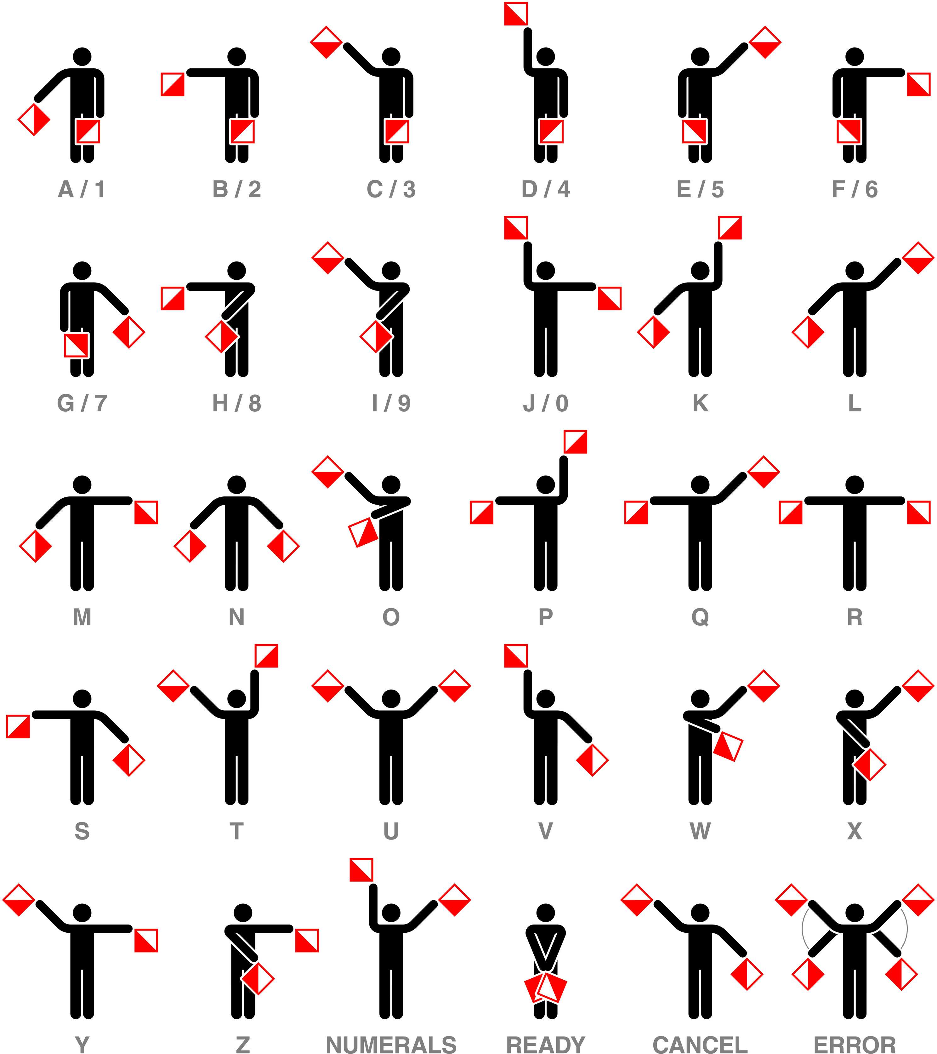
Semaphore flag template and reference sheet

