Life Cycle Of A Chicken:

Stage 1: Egg Fertilization
The first stage of the chicken life cycle is the egg getting fertilized.
Usually roosters will try to court the ladies and put themselves forward as the best rooster for the position of flock husband.
However hens are quite calculating in their selection of a mate. They consider things like appearance, attentiveness and food finding. All of these things give her some idea of the health of the rooster, his ability to find food and whether or not he will make a good flock leader.
Mating behavior involves rituals such as tidbitting where the rooster will find something interesting and start calling the hens. He will indicate the food by picking it up and dropping it repeatedly until the hen comes to investigate.
The rooster that wins out will usually be the healthiest and best of the bunch.
He will perform the courtship dance to indicate his interest.
The mating is a brief and precarious thing.
All of this takes less than a minute and when they are done she will shake out her feathers and go about her business as usual.
Once the hen and rooster have mated the sperm will begin its long journey to fertilize the egg.
Fertilization occurs in the infundibulum – the part of the reproductive tract that follows on from the ovary. The egg only remains in the infundibulum for around fifteen minutes so it is a small window of opportunity.
If the sperm does not implant itself here the egg will be sterile.

Stage 2: Egg Embryo
Hens lay no more than one egg per day as the process of laying an egg is governed by the presence of sunlight. The lack of natural light during the winter months means that even fewer eggs are laid during this time of the year. A hen will keep laying around one egg per day until she has a dozen eggs – also known as a clutch. The hen will continue to lay eggs in an effort to produce a clutch of 12. Once an egg has been laid, the hen will leave the nest, causing the embryo to cool and suspending its development. As long as the nest temperature stays warm enough, an embryo can remain suspended for up to two weeks until the hen has managed to lay a full clutch.
Once she has produced a clutch of eggs the hen will stop laying and start brooding, which involves sitting on the eggs for three weeks while the embryos develop. This means the eggs should all hatch at the same time.
The chart gives the highlights of each day’s development of the chick.
- Day 1: Development of the germinal disk begins.
- Day 2: Tissue development starts as does blood circulation.
- Day 3: Heart starts to beat and blood vessels are visible.
- Day 4: Amniotic sac starts to develop.
- Day 5: Elbows and knees develop and their eyes are visible whilst candling.
- Day 6: Beak starts to form and voluntary movement starts.
- Day 7: Comb begins to grow.
- Day 8: Feather follicles start to appear and ear canals open.
- Day 9: Claws begin to develop and embryo now looks bird-like.
- Day 10: Egg teeth and claws are formed.
- Day 11: Tail feathers start growing.
- Day 12: Feathers starting to appear.
- Day 13: Leg scales start to appear and they have light covering of feathers over their body.
- Day 14: Head turns to pipping position.
- Day 15: Chick will consume egg white.
- Day 16: They are now completely feathered.
- Day 17: Egg white is now absorbed and their head is between their legs.
- Day 18: They are almost fully grown now. Yolk sac still outside the body and their head is under their right wing. If your eggs are in the incubator this is lockdown day.
- Day 19: Yolk sac moving into the body and embryo now occupies all the space except the air cell.
- Day 20: The Yolk sac is absorbed and umbilicus now closed. Embryo starts to breathe air and becomes a chick. This is where the pipping starts!
- Day 21: Also known as hatch day. Hatching is usually accomplished within eighteen hours but can drag on a little.

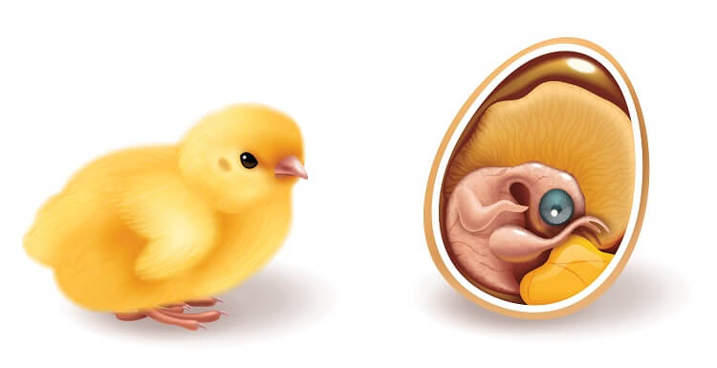

Stage 3: Chick
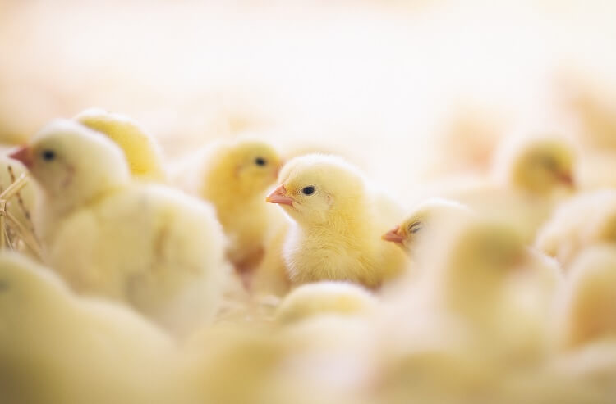
Chicks learn things very quickly especially if they are raised by a broody hen. She will teach them all the good things to eat, things to stay away from and dangers to be aware of. A mother hen and her chicks is an endearing sight.

While some chicks may die within a few short days of hatching, the majority will survive unless they have something drastically wrong with them. Problems such as genetics, incubator problems or infections can all cause high mortality rates in chicks.
The biggest dangers to young chicks and pullets is coccidiosis and Marek’s disease.

Stage 4: Pullet (Teenager)
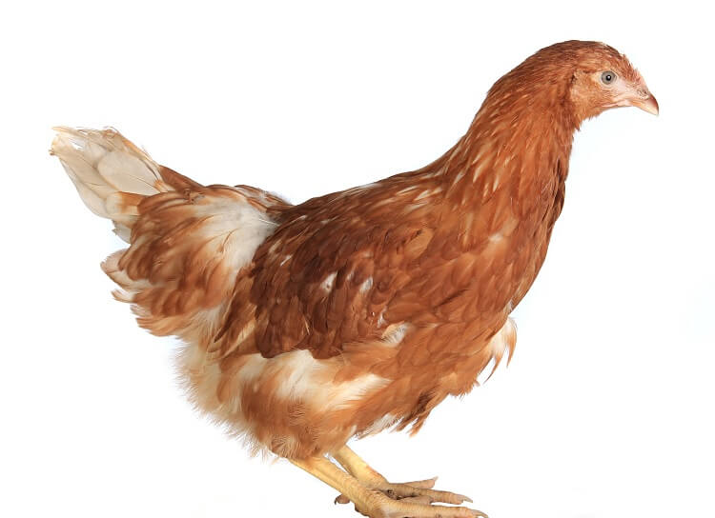
A chick becomes a pullet or cockerel at four weeks of age and lasts for around 12 weeks.
This can be considered the awkward teenage stage – they look artless, gawky and quite unsure of their place in the world.
It will be during this time that the sexual differences will become apparent in most breeds.
The pecking order is a hierarchical system in which chickens self organise themselves into an importance rank.
Every bird knows their place in the flock and birds can move up or down the ladder depending on a variety of things. Such behaviour usually consists of pushing, chest bumping, stare downs and pecking – rarely does this behaviour result in serious injury.
The young chickens will now have to learn their place in a newer and larger pecking order.
Cockerels may try to challenge the other roosters but they are usually quickly and firmly put in their place and will remain subordinate until the head rooster starts to fail.
The same will happen with the pullets.
Older and higher ranking hens will ensure that the social order is kept and the pullets will have to work their way up gradually.

Stage 5: Hen (Adult)
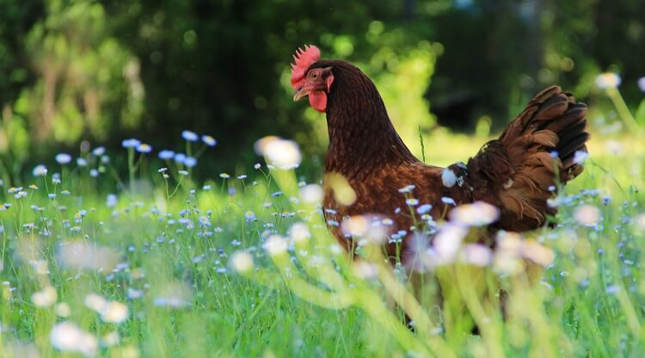
Now we come to the final stage of their life cycle.
There is a slight difference of opinion in the poultry world as to the difference between a pullet (teenager) and a hen (adult).
Some people will say that a hen under one year of age is a pullet, whilst others will tell you that once a pullet has laid her first egg she becomes a hen. Regardless of which definition you choose – it all boils down to sexual maturity.
A cockerel becomes a rooster once he reaches sexual maturity.
Hens usually start to lay around the twenty week mark on average. Their first eggs will be small, infrequent and possibly misshapen.
.
The average chicken can live anywhere from 3 to 8 years.

