Moving and Handling  Can you draw small circles, large circles, small squares, large squares (clockwise and anti-clockwise) and zig zag lines?  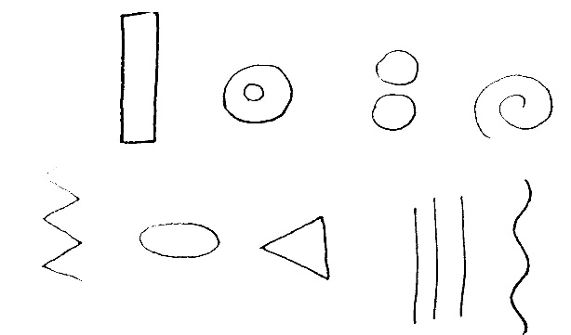  You could also do some Cosmic Yoga with Diggory the Dump truck here:  https://www.youtube.com/watch?v=_v9T9Fxg_TQ | Writing  Can you create a story map of the ‘Naughty Bus’ after watching the online learning videos on Monday and Tuesday?  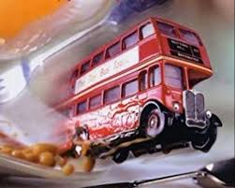 | Understanding the World  In the story, the Naughty Bus is a London Bus. Can you research some of the famous landmarks in London with help from an adult?  Here is a video you could watch:  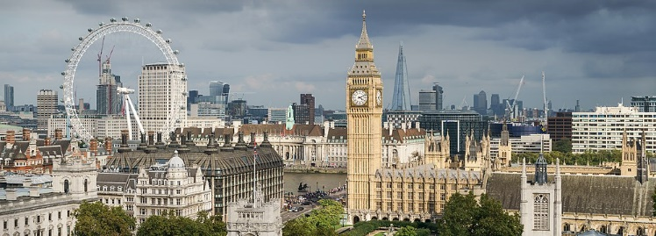  https://www.youtube.com/watch?v=MuDAUa0XSHI  Challenge: Can you create a London scene drawing/craft?
Being Imaginative  Can you imagine you are a bus driver? Remember to charge your passengers for their bus tickets. How much is your ticket going to cost?  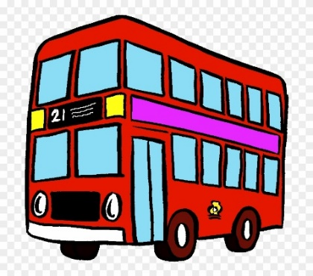 | Speaking and Listening  Can you tell a grown up what your favourite part of the Naughty Bus story is and why?  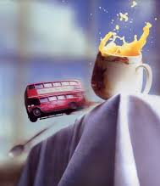 | Phonics  Using the tricky words we have learnt so far, can you make and play a game of snap?  no  I  go  to
Useful links
- https://www.topmarks.co.uk/
- https://www.purplemash.com/sch/inspireacademy
- https://new.phonicsplay.co.uk/
- https://www.ictgames.com/mobilePage/index.html

