Understanding of the World  As part of our new ‘Transport’ topic, can you talk about the different forms of transport? Which forms of transport have you used?  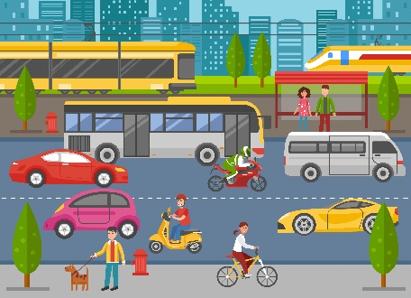 | Literacy  Can you write a list of some of the different forms of transport you know?  Remember to use your robot arms to sound out the different words.  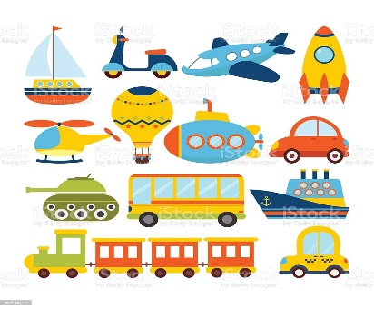
Expressive Arts And Design  Can you learn and perform a Nursery Rhyme related to transport? Here are some suggestions:  - Wheels on the bus  - Down at the station  - A sailor went to sea  - Row row row your boat  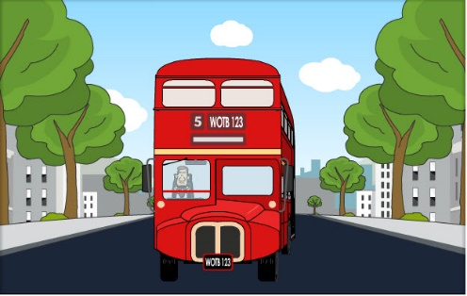 | Physical Development  Imagine you are a train/ aeroplane/bus/car/bicycle/motorbike/boat. How would you move? Can you practise moving like different forms of transport?  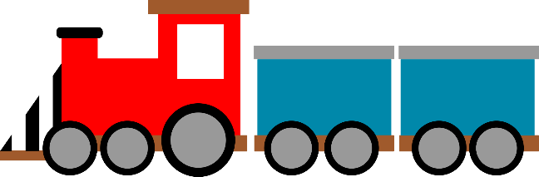
Useful links
- https://www.topmarks.co.uk/
- https://www.purplemash.com/sch/inspireacademy
- https://new.phonicsplay.co.uk/
- https://www.ictgames.com/mobilePage/index.html

