Handwriting  Concentrate on the curly caterpillar handwriting family. Practise your letter formation from start to finish.  Please see the video on our class page to help you:  https://www.inspireacademyashton.org.uk/  home/classes/year2/year-2-home-learning/  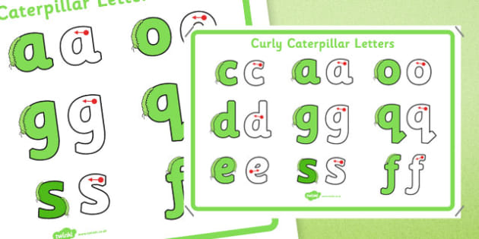 | P.E  It’s time to get active at home!  You could complete the following circuit:  - 10 star jumps  - 5 burpees  - 5 press ups  - 10 mountain climbers  - 10 squats  - 5 lunges – remember to swap legs | Science  Materials  Can you find items around your house that are made from different materials?  Can you talk about the properties of each?  E.g. rough, smooth, hard, rigid.  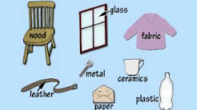 | 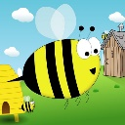  Spellings  We’re starting to learn some spelling rules. Here are our class spellings for this week.  The ‘n’ sound spelt ‘kn’ and ‘gn’ at the beginning of words  knock gnat  know gnaw  knee gnash  knitting gnome  knife gnarled
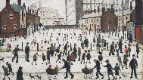  Art  L.S. Lowry  Watch the following video on Lowry.  http://www.bbc.co.uk/education/clips/z3gkq6f  Complete some research on him and look at some of Lowry’s paintings. What colours are used? How much detail? What can you see in the pictures?  Can you create a mind map showing what you have learnt about him? | Geography  Compass points  Follow the compass directions on the worksheet attached.  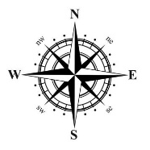 | PSHE  Being Me  Watch the following story - https://www.youtube.com/watch?v=D5ibh-RzwIU  After listening to the story, discuss with your grown up: what happened in the story? How was Jenny feeling? How did she feel when she talked about her worries?  Do you have any worries? What could you do if you were worried about something?
Useful links
- https://www.topmarks.co.uk/
- https://www.topmarks.co.uk/maths-games/hit-the-button
- https://ttrockstars.com/
- https://www.purplemash.com/sch/inspireacademy
- MathShed - Mathematics game for school and home

