Literacy  Think of our story ‘The Train Ride’. Imagine that you are going on a journey on a train. What do think you would see? Tell an adult or you could even draw a picture.  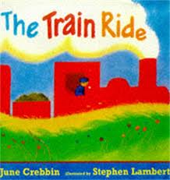 | Maths  This week we will be looking at comparing two groups of objects, saying when they have the same number.  Can you gather some objects from around your home and compare two groups and identify when they have the same number of objects in them?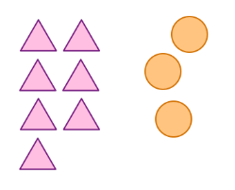 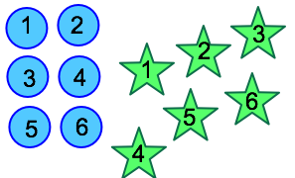 | Phonics  Hang large pieces of coloured fabric or card outdoors. The adult says a word that rhymes with one of the colours of card or fabric and the children run to that colour e.g. bed and they run to the RED, bean they run to GREEN.
Being Imaginative  Can you make up a silly song?  I would love to see a video of your silly song on Tapestry or Twitter.  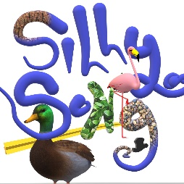 | Physical Development  In PE, we are running safely, negotiating space and adjusting speed or direction to avoid obstacles. Can you build an obstacle course in your house or your garden to demonstrate these skills?  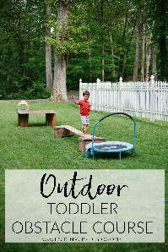 | People and Communities  Can you draw a picture and put it in your window to spread happiness and smiles to all the people who see it?  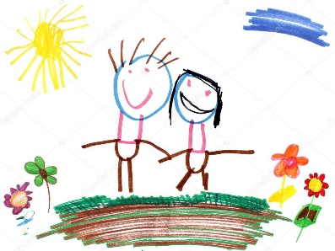
Useful links
- https://www.purplemash.com/sch/inspireacademy
- https://www.topmarks.co.uk/maths-games/3-5-years/counting
- https://www.bbc.co.uk/teach/school-radio/nursery-rhymes-a-to-z-index/z4ddgwx
- https://new.phonicsplay.co.uk/resources/phase/1

Nursery’s Home Learning- Week commencing 25th January – Topic - Transport
Set yourself a challenge- How many of these learning challenged can you complete?

