Literacy  Think of our story ‘The Train Ride’. Can you put some actions to the story? For example, make binoculars with your hands and put them to your eyes for ‘What shall I see?’  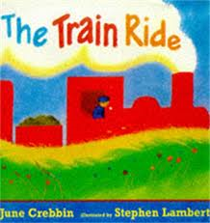 | Maths  This week we will be looking at two groups of objects and recognising when each group has the same number. We will be doing lots of sharing activities to help with this. Can you get two of your favourite teddies and some objects and share them out so they have the same?  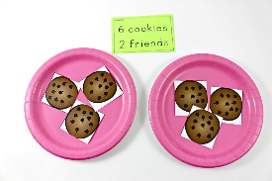 | Phonics  Introduce a puppet who can only talk in rhyme. Put out objects for the puppet to buy and put in its shopping bag. But the puppet needs help, because he/she will say a word that rhymes with one of the objects e.g. if the puppet wants to buy a pear, she/he may say „bear‟ – the children help the puppet to pick out the objects he/she wants to buy.  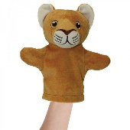
Understanding the World  Can you think about a special time or event that you have shared with family or friends? Talk about it with an adult or even draw a picture. It might be a birthday or a wedding or a special holiday that you been on. | Physical Development  Can you spend some time with your Fine Motor pack? I would love to see lots of pictures on Twitter or Tapestry of you working on these skills.  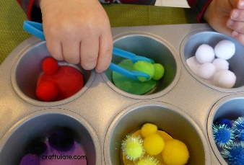 | Singing  Go on BBC school radio and sing some of your favourite nursery rhymes  https://www.bbc.co.uk/teach/school-radio/eyfs-early-years/z6bgnrd  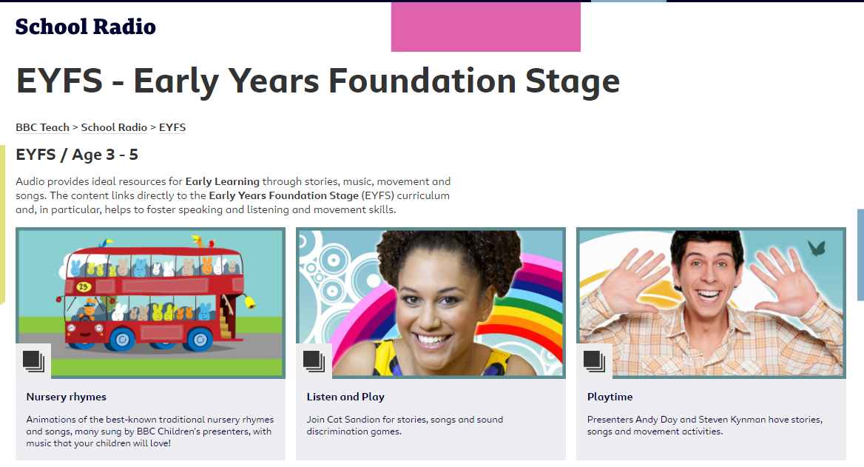
Useful links
- https://www.purplemash.com/sch/inspireacademy
- https://www.topmarks.co.uk/maths-games/3-5-years/counting
- https://www.bbc.co.uk/teach/school-radio/nursery-rhymes-a-to-z-index/z4ddgwx
- https://new.phonicsplay.co.uk/resources/phase/1

Nursery’s Home Learning- Week commencing 1st February – Topic - Transport
Set yourself a challenge- How many of these learning challenged can you complete?

