Literacy  Read your favourite book. I want to see lots of pictures of you reading your favourite book.  Can you tell your adult which part is your favourite? Who is your favourite character? Why?  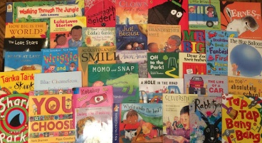 | Maths  This week we are looking at positional language; in, next to, behind, on and under. Can you get your favourite teddy and put it in different positions and tell your adult where it is? | Phonics  Listen and play along https://www.bbc.co.uk/teach/school-radio/eyfs-listen-and-play-billy-goats-gruff/zr3yt39  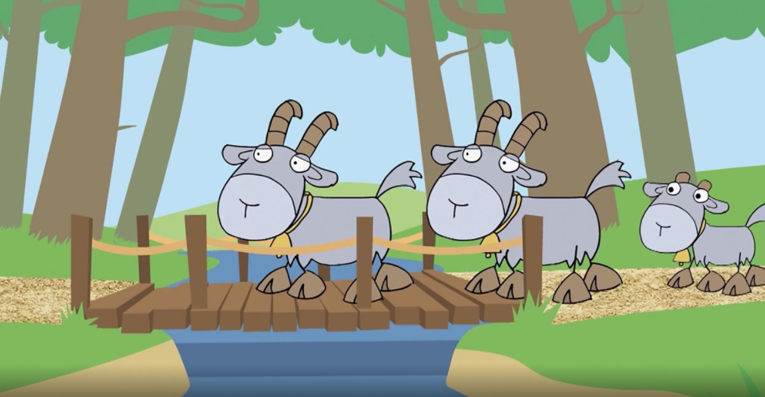  Can you identify the sounds in the environment, rhyming words and join in with the repeated refrains?
Singing  In Nursery, we are singing lots of Nursery Rhymes to help us with our rhyming. Can you spot rhyming words in these songs?  https://www.bbc.co.uk/teach/school-radio/nursery-rhymes-a-to-z-index/z4ddgwx  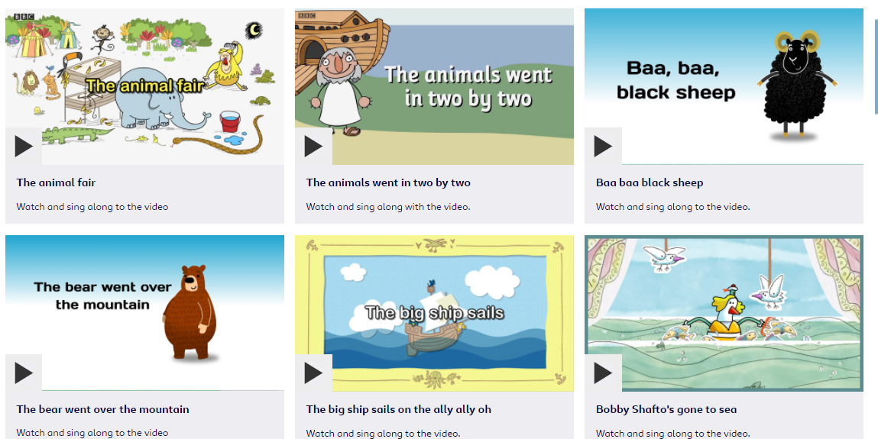 | Physical Development  In PE, we are completing Joe Wicks challenges. Can you join in with us?  https://www.youtube.com/watch?v=mhHY8mOQ5eo | Expressive Arts and Design  Can you help your adult in the kitchen? Help them prepare breakfast or lunch, bake a cake or make biscuits.
Useful links
- https://www.purplemash.com/sch/inspireacademy
- https://www.topmarks.co.uk/maths-games/3-5-years/counting
- https://www.bbc.co.uk/teach/school-radio/nursery-rhymes-a-to-z-index/z4ddgwx
- https://new.phonicsplay.co.uk/resources/phase/1

Nursery’s Home Learning- Week commencing 18th January – Topic - Transport
Set yourself a challenge- How many of these learning challenged can you complete?

