Literacy  Listen to the story The Train Ride. This is one of topic books for this half term.  Can you join in with the repeated refrains?  https://youtu.be/RoEvHK_mP4Y  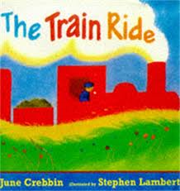 | Maths  Can you take 1, 2, 3, 4, 5 objects to your adult?  Watch our online video to help you with this.  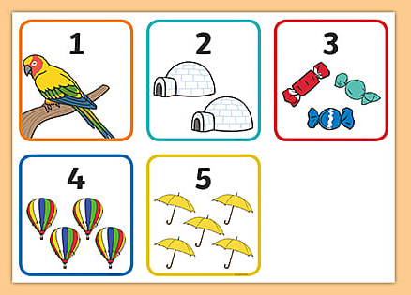 | Phonics  Adults, can you put some simple objects in a bag, allow your child to pick one at a time and encourage them to say a word that rhymes with that object. Remember, when we are rhyming we can use silly words too.  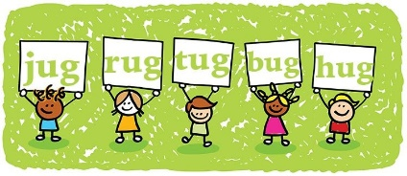
Singing  Sing The Wheels on the Bus  https://youtu.be/ki_R_4FcFK0 | Physical Development  Can you move around like a train?  Are you a high-speed train or a steam train? | Expressive Arts and Design  Miss Hindley has done a video to show us how to make playdough. If you don’t have playdough at home, can you make some and have a go at this fine motor skills activity?  https://youtu.be/DrBsNhwxzgc
Useful links
- https://www.purplemash.com/sch/inspireacademy
- https://www.topmarks.co.uk/maths-games/3-5-years/counting
- https://www.bbc.co.uk/teach/school-radio/nursery-rhymes-a-to-z-index/z4ddgwx
- https://new.phonicsplay.co.uk/resources/phase/1

Nursery’s Home Learning- Week commencing 13th January – Topic - Transport
Set yourself a challenge- How many of these learning challenged can you complete?

