Literacy  Listen to the story Duck in the Truck. This is one of topic books for this half term.  Listen carefully, can you hear the rhyming words?  https://youtu.be/m2pN3fI6eGI  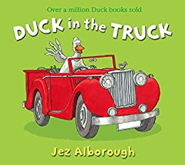 | Maths  Keep practising counting to 10.  Can you show your adults a number on your fingers, a number of jumps, or claps? Can you represent numbers with marks on paper? Pick a number, can you draw that number of dots?  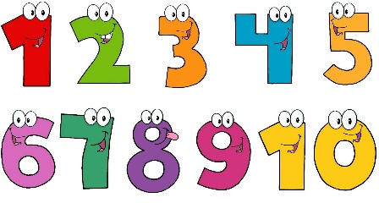 | Phonics  Adults, can you clap a simple rhythm to your child and ask your child to clap it back?  When your child can do this easily, make it more challenging; add a stomp or a knee tap.
Speaking & Listening  Have a look around you and say the rhyme;  [Child’s name, child’s name] what do you see?  Child to say; I see a [object, person etc.] looking at me!  Encourage child to reverse back;  [Adult, adult] what do you see?  Repeat this as many times as possible. | Physical Development  Have a go at a Jo Wicks workout!  https://youtu.be/uqLNxJe4L2I  It is quite challenging, but you will feel great after it.  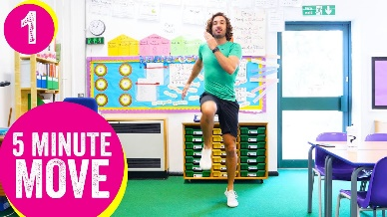 | Expressive Arts and Design  Choose one of your toys. Can you build a story around it?  Does your teddy need rescuing from the top of a tower?  Is your car the new Batmobile?
Useful links
- https://www.purplemash.com/sch/inspireacademy
- https://www.topmarks.co.uk/maths-games/3-5-years/counting
- https://www.bbc.co.uk/teach/school-radio/nursery-rhymes-a-to-z-index/z4ddgwx
- https://new.phonicsplay.co.uk/resources/phase/1

Nursery’s Home Learning- Week commencing 5th January – Topic - Transport
Set yourself a challenge- How many of these learning challenged can you complete?

