Science- living things (45 minutes)  Year 5’s Home Learning- Week commencing 4th January 2021  Complete one or two activities per day from the learning grid.  Can you create a life cycle of a chicken?  Use the power point provided and the information sheet to create a life cycle with detail about each stage.  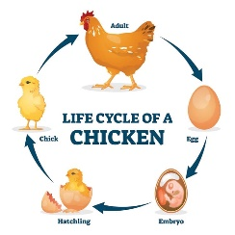 | Art- The tin forest (45 minutes)  Watch and listen to the story. Pay attention to the illustrations. https://www.youtube.com/watch?v=_j_XPFxy5js  Look at how the forest is made from metal objects such as: screws, cans, pipes etc.  Have a go at drawing: trees, leaves and flowers in this same style  pause at 1:20 and 2:10 to help you. | Computing- reading blog (45 minutes)  In school, you have started a reading blog about one of your favourite books. Now you need to write up the main section of the blog (like a book review) Remember… DON’T give away too much of the story.  Here are some example of blogs to remind you.  Library Girl and Book Boy – Showcasing the newest books for ages 4-11ish!  http://mundiekids.blogspot.com/ | PSHE- goals (30 minutes)  As this half term is going to be very different. Set yourself some goals to focus on and work towards.  Use the stars for ideas of what the goals could be.  e.g. Become a rock hero, read a full chapter book each week, learn how to send emails etc. They can be as big or small as you like. But they must be realistic!
RE-Are Sikh stories important today? (45 minutes)  Choose your favourite ever book.  Create a mind map, with your favourite book in the middle and answer these questions.  Why is this your favourite? Is it because you like the story or is it special because of who bought it for you? Or is there another reason? What’s the meaning behind it? What can we learn from this text? Could there be a better ending? Would you tell a small child this story? Did the story really happen? Could you give it a different ending? | Music- Make you feel my love by Bob Dylan (Adele version) (30 minutes)  Listen to the song. https://www.youtube.com/watch?v=9m1YhLqeTNQ  How does it make you feel? Do you like the song? What does it remind you of?  Can you learn the lyrics to the song? | PE  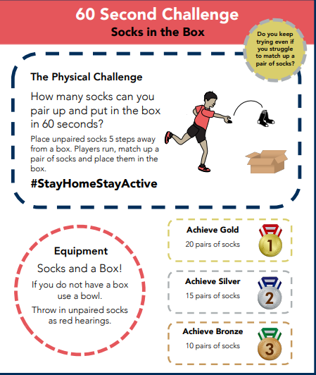 | French-months of the year  (30 minutes)  Can you recap the months of the year?  Use the link below to help you with the pronunciation  https://www.youtube.com/watch?v=JyROOY4RPJg  reate a grid with 12 sections. Write one month in each section (in French) and draw a picture to represent what might happen in that month.  