French  Year 4’s Home Learning – 25th – 29th January 2021  Complete all the activities below, one per day. Post on twitter or send me your work via email.  LC:- Can I use the plural for animals?  (Watch the video link on the school webpage) | Computing  LC:- Can I compose for effect?  Listen to adverts on the radio or tv. What is the music like? What feeling does it give you? Why do you think this is? Is it done on purpose?  Write a jingle / lyrics to promote the Tameside Towns. Consider if your jingle should be happy / lively / slow / fast. What feeling do you want to convey?  You can use any instruments at home / demo settings on keyboards etc… or just write a rap/song to sing. | History  LC:- Can I discover a famous Ashtonian?  As a pre-teach ahead of our next History focus, can you find out about Hannah Mitchell, a famous Ashtonian? Why is she famous? What was her early life like? What or Who influenced her beliefs?  [HINT: She has a Blue Plaque somewhere in Ashton, with her name on] | PHSE  LC:- Can I create a Class Charter?  Thinking about our job roles in our community, create a charter of rules we could all follow to ensure our community is kept safe and works efficiently.  Write these rules out on a poster and make it colourful and engaging!  CH: If you wanted to, could you cut it up into a jigsaw for someone to piece back together?
Science  LC:- Can I review Scientific Vocabulary?  Within our unit there is a lot of Scientific Language we need to use. The names of each State of Matter and this phrase itself, processes, condensation and so on. Let’s take a moment to recap what this Scientific Language means.  Match the words with the meanings below. You can print out and colour code or Re-write the words and correct meanings next to each other. | RE  LC:- Can I explain the meanings of a Seder Meal?  Using the reference sheet below, research and explain the meanings behind the Seder Meal.  The meanings link to the story of Moses bringing his people out of Egypt.  CH: Could you recreate a version of this meal yourself, based on these ingredients? | PE  LC. Can I tackle the Gherkin?  The Gherkin is a very famous building in London. It has 1,037 steps over 38 floors. That's an average of 27-28 steps per flight. Can you ascend that many steps this week? Use your stairs at home or flights of steps out and about. Good Luck! #thighburner | Music  LC:- Can I recognise themes in different genres?  Continuing our theme of “Being Yourself” or “It’s ok to be different!” Can you find songs with this theme in different genres? (Gospel, Disco, Jazz, Blues etc…)  What in the lyrics SHOWS you the song is related to this theme?

Useful links
- https://www.inspireacademy.org (School website where Video Learning and Home Learning Pack can be accessed)
- SPELLINGS – These have been updated and challenges set on Edshed / Spellingshed. CAN YOU COMPLETE 20 CHALLENGES?

SCIENCE:
SOLID | Liquid turns into a Solid during this process
LIQUID | This state of matter has tightly complacted particles and does not change shape unless it is put through a Scientific Process.
GAS | Turn a Liquid to a Gas by ‘Heating’
WATER VAPOUR | Solids turn into Liquids during this process
STATES OF MATTER | This state of matter spreads into and takes the shape of any container it is in. The particles are loose but not tight together.
EVAPORATION | Liquid or Solid particles that fall from a cloud
CONDENSATION | Materials can be one of these things. Some can change from one to the other after being put through a Process.
PRECIPITATION | Turn a Gas into a Liquid by ‘cooling’
MELTING | Water that takes the form of a Gas, after being evaporated (heated up)
FREEZING | This state of matter can spread ANYWHERE. The particles are very loosely arranged meaning it fills any space it moves into.

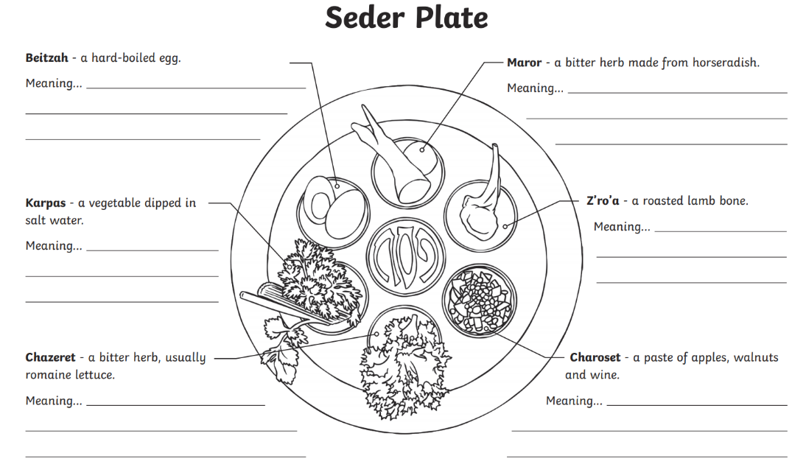
RE:

