French  LC:- Can I say animal names?  Get google translate onto your device (This can work on PS, Xbox etc…) Type in the animals below and listen to how they sound. Try to spell each without looking at your screen. How close were you?  Now write them correctly. Draw a picture of each and write the correct word on. Practice saying them and tweet your efforts or email in the pictures with correct spellings on. | Art/DT  LC:- Can I sketch in detail?  Using your sketching skills (light strokes) find an image online of a famous mill in Ashton. Choose one part of the mill (eg: the tower or doorway) and sketch just this specific part. Look closely and pick out the small details. [you could have a walk and sketch the building in real life!] | History  LC:- Can I find out about local past?  If you walk through Ashton, Denton and especially Oldham, there are many old mills you to see. (There are around 70, just in Ashton!)  What industry was most common in Ashton, Denton and Oldham. Can you find out about the names of local mills and why they have these names? | PHSE  LC:- Can I identify different roles in my school community?  Think about all the jobs that we need in a school. List as many as you can (try for at least 7)  Write down WHY these jobs are important and what might happen if just one of those things wasn’t happening.  WE ALL WORK TOGETHER, EVERYONE IS IMPORTANT!
Science  LC:- Can I consider how liquids can be different?  Please look through the images below, and consider the research questions first.  TASK: Freeze some cooking oil, lemonade and water in a container, for the same amount of time. What do you notice about how they look? Why has this happened?  Now put some lemonade in a cup with oil on the top of the lemonade. Freeze this. Has anything happened? | Geography  LC:- Can I find a position on a map?  Look up the mills, listed below, in Ashton and their addresses.  Find and label them on a map (an A-Z or google maps will do this)  Look at the Geographical Features around them. Why do you think these mills were positioned here? Can you find any old images of these mills from centuries ago?  Email or tweet your maps with labels and any old images you may find. | PE  LC:- Can I replicate Spartan Warrior training?  Follow the Circuit Training worksheet attached to do 300 exercises in one session.  They can all be done indoors.  We are doing this again this week as there was a delay getting the worksheet out to you all. Apologies. | Music  LC:- Can I recognise themes?  https://www.youtube.com/watch?v=28JFuuJXxh4 23 Skidoo  https://www.youtube.com/watch?v=XLFEvHWD_NE This is Me – Green Light session  Listen to both songs on the links above.  What Genre/style of music is each track?  What instruments can you hear?  Describe the tempo?  CH: Can you explain how the dynamics are different? Where in the song does the dynamic change? Why?  Are both songs saying the same thing?  Make notes / write down your thoughts, THEN, read the extra note below.
Year 4’s Home Learning – 11th – 15th January 2021
Complete all the activities below, one per day. Post on twitter or send me your work via email.

Useful links
- https://www.inspireacademy.org (School website where Video Learning and Home Learning Pack can be accessed)
- https://www.topmarks.co.uk/
- https://ttrockstars.com/

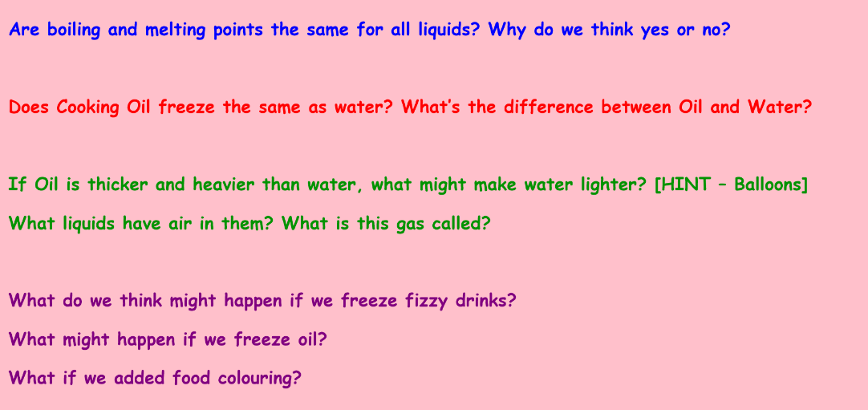
SCIENCE:
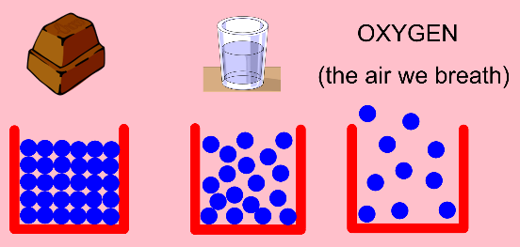

A recap of Solids, Liquids and Gases Temperature scales
This shows how the particles in each Liquids have different freezing and
fit together. boiling points. WATER, freezes at 0 Celsius Research Questions
and boils at 100 degrees Celsius.

MUSIC:
PSHE LINK: Style of music is personal, no style is rubbish or not better or worse than any other, it’s all opinion. We all like different things and that’s good.
We are all different, music styles can also be different but all can have the same message. No matter our differences, we can all be united… that’s one of the many powers of music!

FRENCH:
Les Animaux: Cat Dog Pig Bird Sheep Fish

GEOGRAPHY:
Mills to find are: Portland Cavendish Guide Bridge Ryecroft Victoria

