Guided Reading
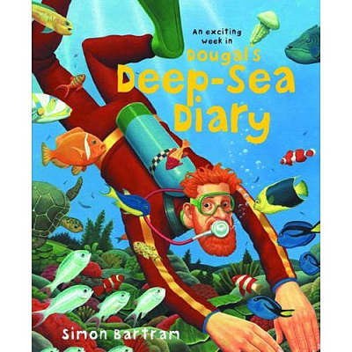

Name……………………………………………………………..
Week beginning……………………………………………..

V I P E R S
- Why was Dougal counting down the hours?
…………………………………………………………………………………………………………………………
……………………………………………………………………………………………………………
- What type of people are the people on the train?
friendly unfriendly

sad scared

- Why?
…………………………………………………………………………………………………………………………
……………………………………………………………………………………………………………

- ‘Maybe this time’ This means…?

he will see lots he won’t see anything

he hopes he will see lots he wants to know what time it is

- Dougal is staying on the boat for a long time?
True or False? Why?
…………………………………………………………………………………………………………………………………………………………………………………………………………………………
- Why did Dougal’s skin go wrinkly?
………………………………………………………………………………………………………………………………………………………………………………………………………………………

V I P E R S
- Was Herbert the star of the show?
……………………………………………………………………………………………………………………………

- Why does Dougal say ‘NOT TODAY, BOYS!’?

he wants to feed them tomorrow he doesn’t want to share his food

he doesn’t want them to eat him he fed them yesterday

- Why did Dougal keep bumping into things?
……………………………………………………………………………………………………………………………
……………………………………………………………………………………………………………………………

- Why does the author use the word ‘uneventful’?

nothing happened he was shocked

lots of things happened he was surprised

- How do you know that Dougal was tired?
………………………………………………………………………………………………………………………………………………………………………………………………………………………..
- What stopped Dougal from sleeping?
……………………………………………………………………………………………………………

V I P E R S
- ‘What a fantastic morning’ This means Dougal…?

hated his morning enjoyed his morning

had an satisfactory morning did not enjoy his morning

- Why does he feel this way?
………………………………………………………………………………………………………………………..………………………………………………………………………………………………
- Ralph found moving the treasure chest easy. True or False?
Explain how you know.
………………………………………………………………………………………………………………………………………………………………………………………………………………………..……………………………………………………………………………………………………………….

- People were excited about the treasure chest. True or False?
Explain how you know.
…………………………………………………………………………………………………………….…………………………………………………………………………………………………………..………………………………………………………………………………………………………………..

- Dougal ‘followed the directions all day and all night’ Does this mean it was a…

short journey quick journey

bumpy journey long journey

