The Amazon Rainforest
The Amazon Rainforest is the largest wet tropical forest in the world and the largest which hosts an extensive ecosystem. Located in South America, with 60% of the Amazon Rainforest in Brazil, 13% in Peru, 10% in Colombia and small percentages located in Venezuela. To put this into perspective, it’s 25 times bigger than Britain.
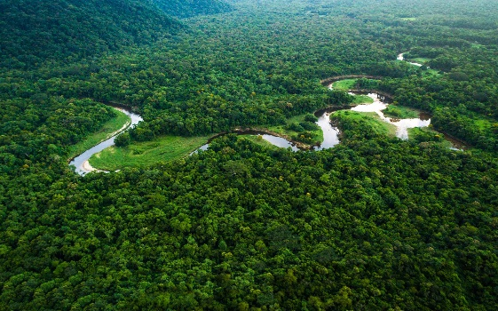
Because of its size, scale and magnitude, the Amazon Rainforest is the most significant ecosystem on our planet: It absorbs over 40% of our global pollution of carbon dioxide and transforms this into the oxygen we need to breathe. For this purpose, it’s often titled as the “lungs of the world”.
The Amazon Rainforest is also the home to the world's largest river by water volume - the Amazon River. Despite being a close second in size, after the River Nile located in Africa, the Amazon hosts the most water and pumps around 58 million litres of water into the ocean every second.
Humans and the Amazon
The Amazon Rainforest is the home of over 20 million people spread over 8 different countries. Known as Indigneous communities (they are native to the Amazon Rainforest), it is believed over 350 different groups have developed livelihoods that’s suited to the unique environment around them.
Human Destruction
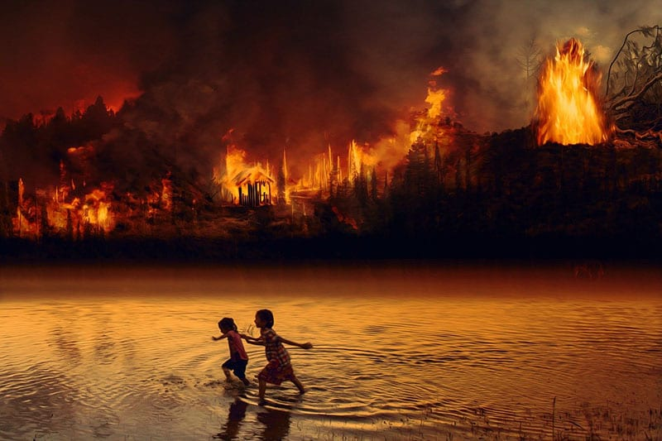
Unfortunately, the Amazon Rainforest hosts desirable materials that are harvested by farmers and large businesses, which has been a global concern for decades. This includes materials such as the following: wood, natural oils, and fruits. Because the Amazon Rainforest has such rich land, deforestation also occurs to create agriculture, otherwise known as farming opportunities. Trees are cut down to create more land to farm rice, citrus fruit, coffee, cocoa beans, tea leaves, rubber and more.
Deforestation creates gaps in the humid canopy of the forest (which in turn dries out the surrounding environment). This leaves areas prone to damaging wildfires that cause mass destruction. In 2019 alone, there were over 40,000 wildfires in the Amazon Rainforest. Together, these wildfires burned over 2,240,000 acres of forest, and sadly killed over 2.3 million animals.
The Amazon’s Different Species
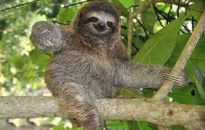
The Amazon is one of Earth’s last refuges for jaguars, harpy eagles, and pink river dolphins, and it is home to sloths, black spider monkeys, and poison dart frogs. It contains one in 10 known species on Earth, 40,000 plant species, 3,000 freshwater fish species, and more than 370 types of reptiles. Over 2,000 new species of plants and vertebrates - including a monkey that purrs like a cat - have been described since 1999
Global projects such as WWF have been working to protect and conserve the Amazon for over 40 years. WWF works to confront the drivers of deforestation, like soy farming, cattle ranching, hydropower, illegal and unsustainable logging in the hope that one day, this beautiful area can thrive once again.

