Reading  Can you listen to the story ‘Mr Gumpy’s Outing’ by following the link below? https://www.youtube.com/watch?v=Mi_DV_DWN8M  Can you be a detective and find any of our tricky words in the story i.e. I, the, to? How many of each tricky word did you find?  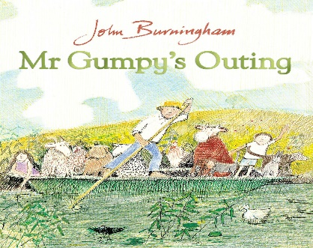 | Being Imaginative  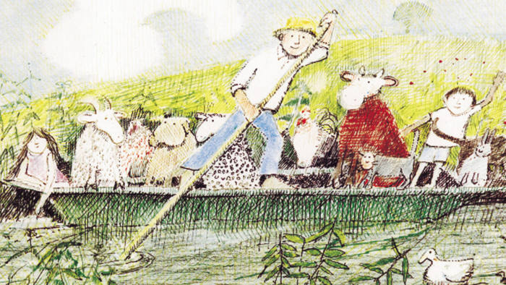  Can you pretend to be each of the different animals from the story ‘Mr Gumpy’s Outing’? Can you move like the animals and make the different noises like them? | Using Media And Materials  Can you make a boat for Mr Gumpy and the animals from the story? Can you think about which material would make the best boat?  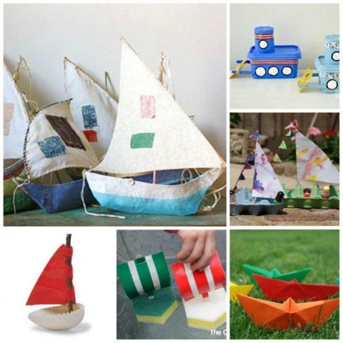
Understanding of the World  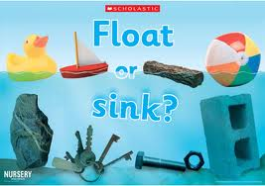  Can you explain what floating and sinking means? Can you get a variety of different objects e.g. a coin, a straw, a building block and investigate whether they float or sink? Can you record which objects float or sink? | Speaking  Can you discuss the differences and similarities between the animals and Mr Gumpy? Do they all have legs? How many? Do they have fur? Do they all eat and drink? What do they eat and drink?  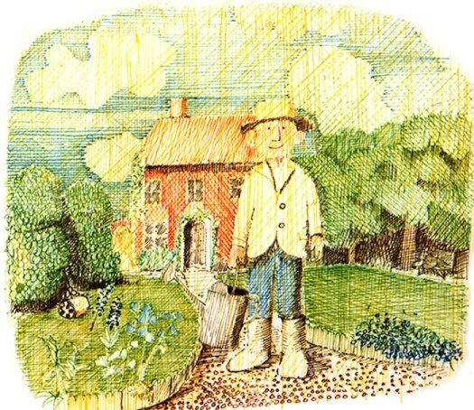 | Writing  Can you write a list of some of the different animals from the story ‘Mr Gumpy’s Outing’? Remember to use your robot arms to sound out each word.  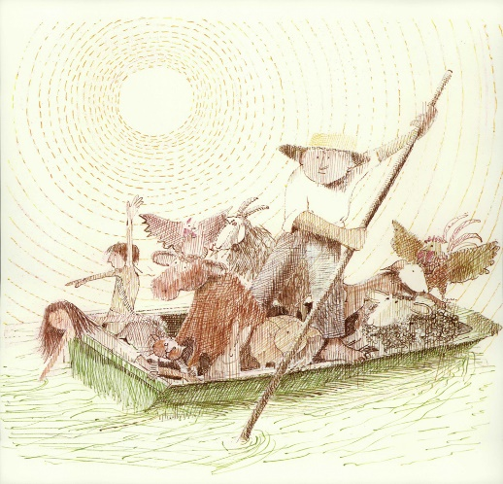
Useful links
- https://www.topmarks.co.uk/
- https://www.purplemash.com/sch/inspireacademy
- https://new.phonicsplay.co.uk/
- https://www.ictgames.com/mobilePage/index.html

