Using Media And Materials  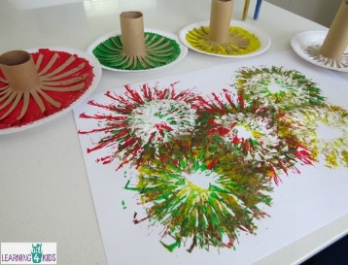  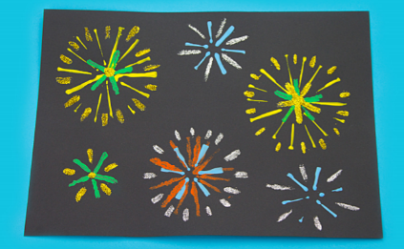  Can you create a bonfire night themed piece of art? You could create a firework effect using cotton buds, cardboard tubes or straws. | Speaking  This week, we will be learning about the people who help us at school.  Can you tell a grown up about some of the people who help us at school and how they help us?  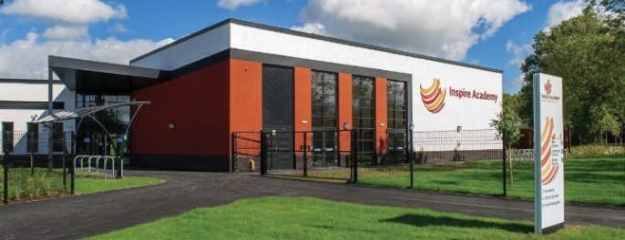
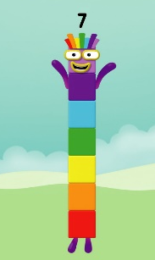  Maths  Our number of the week is 7.  Can you represent 7 in different ways? This might include; 7 fingers, 7 claps, 7 star jumps, drawing 7 spots, writing the numeral 7, finding one more and one less than 7 etc.  Watch the Numberblocks introduction to 7 here: https://www.bbc.co.uk/iplayer/episode/b08pgqt4/numberblocks-series-2-seven | Phonics  How many words can you think of which begin with the sound ‘n’? Can you use robot arms to segment the words; nap, nut, net, nod?  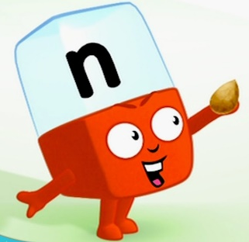  Can you practise writing the letter ‘n’? You could use your magic finger whilst forming the letter in the air or on the ground. You could also practise forming ‘n’ in shaving foam or using playdough.
Useful links
- https://www.topmarks.co.uk/
- https://new.phonicsplay.co.uk/
- https://www.ictgames.com/mobilePage/index.html

